Slide 1



Slide 2

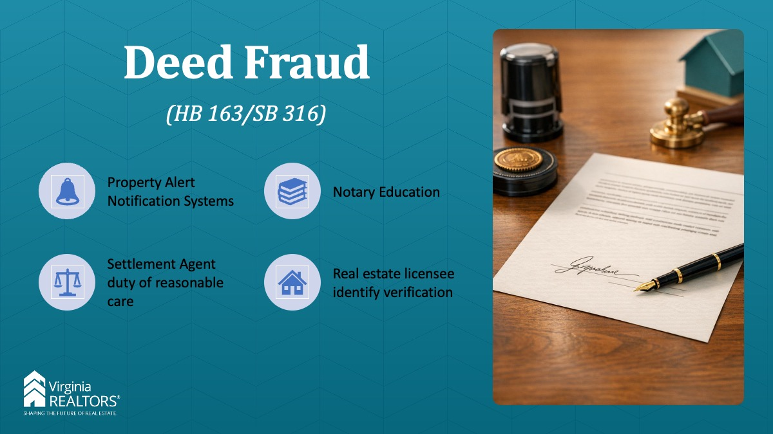

Instructor:

Introduce speaker. Note for this sales meeting kit, we will not go over every single bill that has passed. Virginia REALTORS® does offer courses for CLE which address these changes and there are multiple resources on their website which go into detail about the ones that impact you the most.

Please take note of when these changes will take place, they are effective July 1st, 2026 unless noted.

The first is the deed fraud bill, HB163 / SB316.

- Starting on July 1, 2027, all localities with a network or system for electronic documents must now offer a property alert notification system to residents. Homeowners will be allowed to sign up to receive alerts if anything is filed with their property address. This will help homeowners monitor if fraudulent liens or deed changes are filed on their property.

- Second: Notaries. Beginning on July 1, 2027, all notaries will have to complete pre-license and continuing education. And starting in July 1 of this year, 2026, notaries will have to provide proof of their commission to obtain a notary seal.

- Third: Starting on July 1 of this year, 2026, All notaries (not just e-notaries) will need to keep a record of notarial acts and will need to maintain those records for 5 years.

- Fourth: Also starting on July 1 of this year, 2026, Settlement agents will need to exercise reasonable care in ascertaining the seller of the property. This could include using the identity verification processes that the notary uses, requiring multiple forms of identification, getting a written statement from the seller’s attorney, reviewing land records, comparing signatures, performing a credit check, or asking detailed questions about the subject property.

What’s the main thing you need to know? That the Commonwealth is taking steps to combat deed fraud and has given property owners with a mechanism where they can be alerted if anyone makes any liens or deed changes on their property. This will at least give them notice so they can take action rather than finding out later when it becomes much harder.

Slide 3

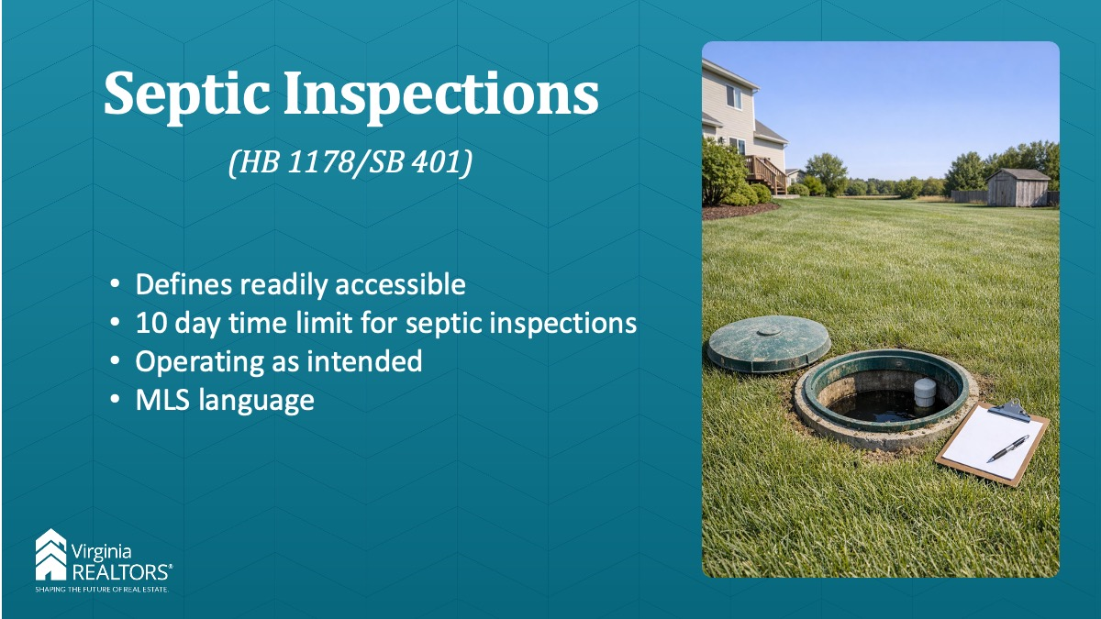

Instructor:

This new law makes changes to the existing septic inspection law:

- Defines “readily accessible” as digging no more than 30 inches.
- Clarified that the 10-day time limit to get your inspection report runs from the first day of the inspection, not the last day someone on the team comes out to the property.
- All septic reports should now indicate whether the system is operating as intended as of the date of the inspection.
- Removes the language requiring a septic inspection to report the advertised bedroom count as listed in the MLS or by statement of the property owner. They are now only required to report what is in the operation permit.

Slide 4

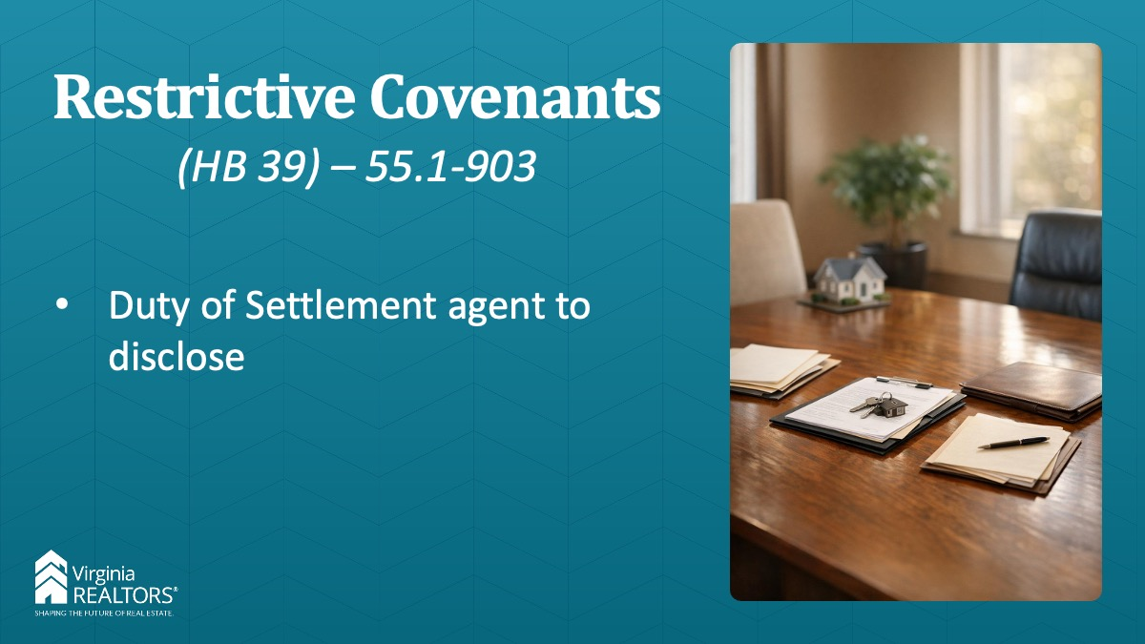

Instructor: This new law builds on a law Virginia REALTORS® worked on several years ago with respect to restrictive covenants – 55.1-300.1. There is still land in Virginia with recorded restrictive covenants that discriminate against protected classes. Several years ago Virginia REALTORS® passed a law that made any such restrictive covenant null and void and set up a process for property owners to have those covenants removed from the record. However, not many people knew about the law. Now, settlement agents who find these restrictive covenants during title searches, will have to notify the client at settlement and make them aware of the process to have the covenant removed if they so choose.

Slide 5

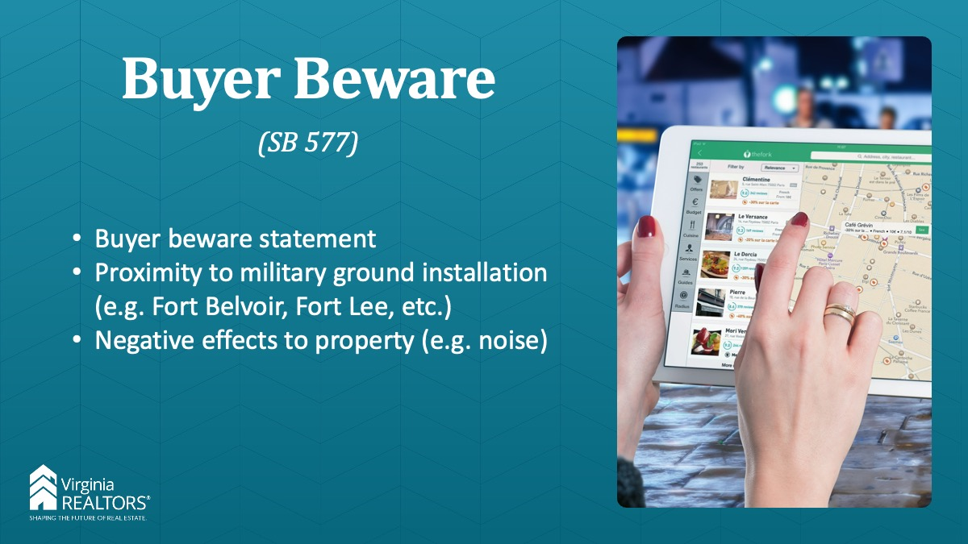

Instructor: We’re going to talk about a few changes on the residential property disclosure act and buyer beware.

Starting July 1, 2026 the VRPDA disclosure form will now include a statement that a buyer should do their own due diligence to determine a property’s proximity to any military ground installation and whether that property may be impacted by noise or other effects of military operations. This idea came from Fort Belvoir which I guess is getting some noise complaints from the surrounding communities.

**Instructor Note: this is different than the mandatory military air installation disclosure, that mandatory disclosure still exists.

Slide 6



Instructor:

The second change to the buyer beware statement language will be added urging the buyer to do their due diligence as to whether a property is located in a locality that has adopted a land-use plan that may provide use value assessment and taxation for real estate classified in § 58.1-3230. When real estate, or a parcel of such real estate, qualifies for special assessment and taxation on the basis of use, and the use or zoning of the real estate changes to a nonqualifying use or zoning, the real estate may be subject to roll-back taxes and interest. IF that happens, and it has not been previously negotiated in the sales contract, the buyer will be responsible for paying all of those rollback taxes. Buyers can research this with the commissioner of the revenue or assessor in the locality where the property is located.

Slide 7

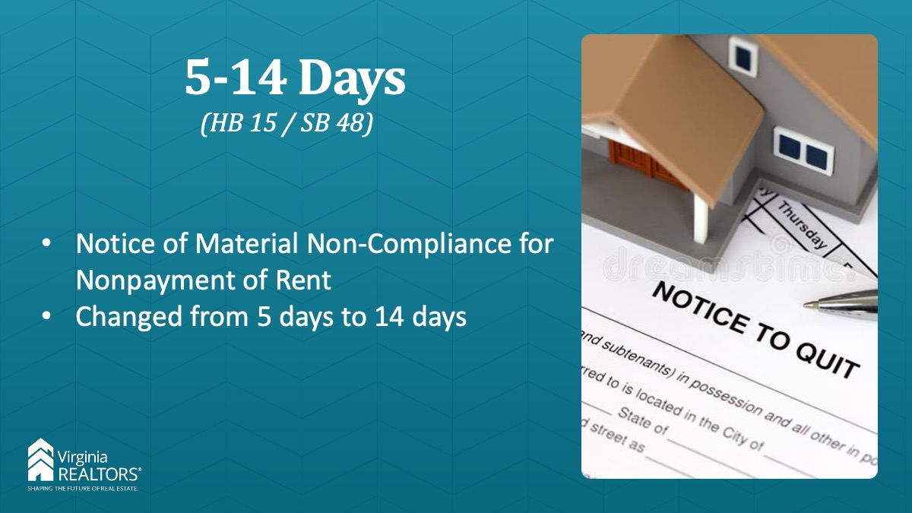

Instructor:

This law is effective on 7/1/26. The time period for a material non-compliance for nonpayment of rent is now 14 days. What does this mean? It means the law now states: “If rent is unpaid when due, and the tenant fails to pay rent within five 14 days after written notice is served on him notifying the tenant of his nonpayment, and of the landlord's intention to terminate the rental agreement if the rent is not paid within the five-day 14-day period, the landlord may terminate the rental agreement and proceed to obtain possession of the premises by filing an unlawful detainer.”

As we move forward with this, make sure to check your lease agreements for when rent is late and work from there.

**Instructor Note: We cannot make an industry wide standard of whether to use the 5 day grace period or not. This is business decision. There is no requirement in the Code for a 5 day grace period unless there is no written lease.

Slide 8

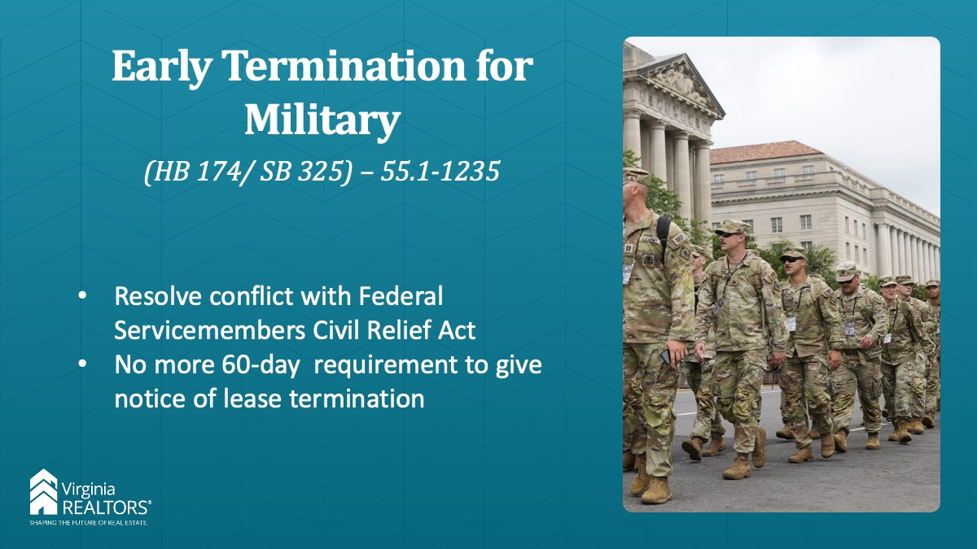

Instructor: Virginia REALTORS® did bring another early termination for military personnel bill to fix, hopefully the last contradiction between the Virginia Landlord Tenant Act and the Federal Servicemembers Civil Relief Act.

Effective July 1, 2026 tenants who are terminating their leases early because of military order will not be limited to 60 days before their orders take effect to make that termination. This was not a limit that existed in the federal act, making ours effectively null and void.

Slide 9

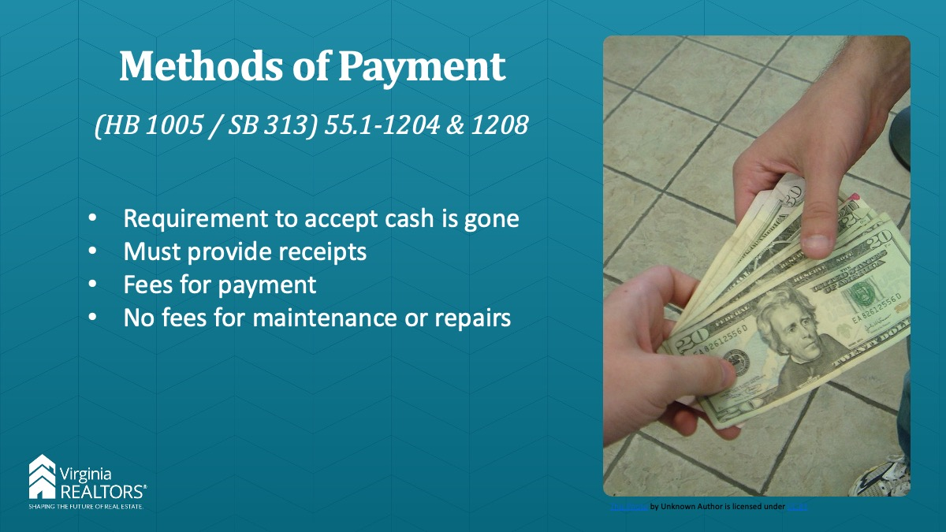

Instructor: The methods of payment bill that passed last year received another tweak. It now says that a Landlord must accept payment of rent or security deposit by check and money order. The requirement to accept cash is gone, which is good because many of our property managers reported this was a security issue for them. If the tenant pays cash or money order, the landlord must provide a receipt (the tenant no longer needs to request this). If a landlord charges a fee for collecting or processing payment, they must still also offer a method of payment without a fee. (this part didn’t change). However, if you charge a fee for collecting or processing payment, the landlord cannot require a tenant to pay a fee in excess of your out of pocket expenses charged by a 3rd party.

Additionally, a landlord is now prohibited from requiring a tenant to pay any fee for the maintenance or repair of any dwelling unit, unless the tenant actually caused the problem.

Slide 10

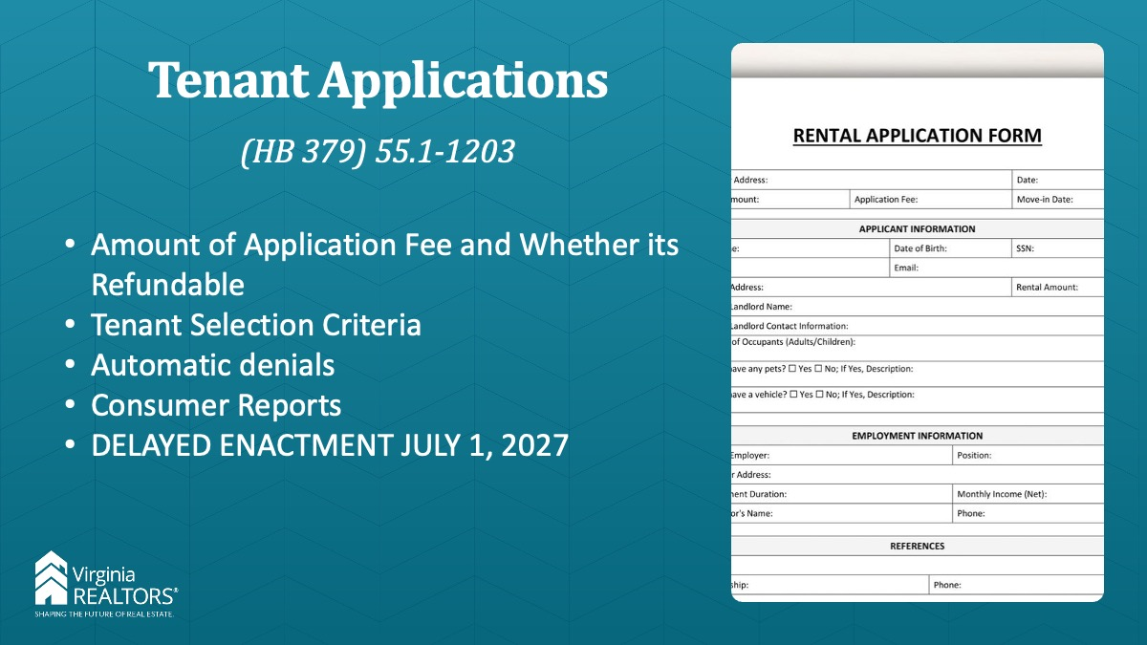

Instructor: This new law is effective, July 1, 2027. The new law states that prior to requesting or collecting any payment or information about a prospective tenant, the landlord must first notify the applicant in writing or by posting in a manner accessible to a prospective tenant (i) the amount of any fees or application deposit that may be charged to an applicant and whether such fee or application deposit is refundable; (ii) the tenant selection criteria applicable to the unit; (iii) any criteria that will result in an automatic denial of the application; (iv) additional criteria that may result in the denial of the application; (v) if the landlord uses a consumer report in his determination, the name and address of the consumer reporting agency; and (vi) the applicant's right to obtain a free copy of the consumer report in the event of a denial or other adverse action and right to dispute the accuracy of information appearing in the consumer report.

What will this look like in practice? It means that before a tenant pays an application fee, or showing fee, or any fee, they must be able to see all the rental criteria and anything that would lead to a denial.

Slide 11

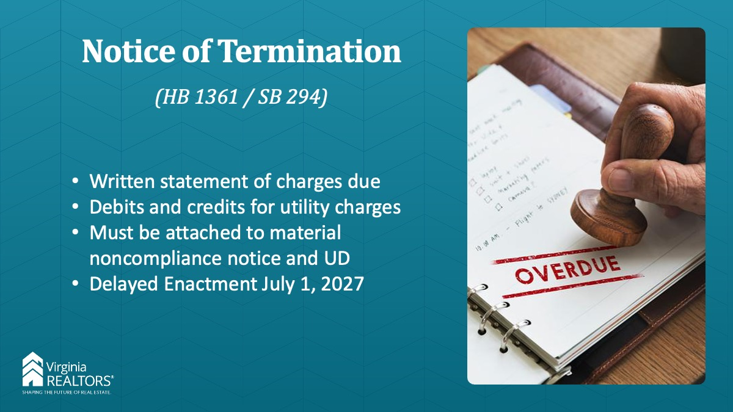

Instructor: Another landlord tenant bill focuses on the written statement of charges due that goes to the tenant. This new law will state that no notice of termination for nonpayment of rent shall be effective unless the notice contains a written statement of charges and payments over the course of the tenancy or the past 12 months, whichever is shorter, including any late charges, attorney fees, costs, and other charges or damages as contracted for in the lease that are due and owing. I imagine most of you are doing this already, its difficult to give a tenant notice that they have to pay within 14 days to stay, without telling them how much they owe, but here we are. Now if the rental agreement provides for the use of submetering, energy allocation equipment, or ratio utility billing the notice must also include all the debits and credits incurred by the tenant for energy and utility bills. Again, I’m sure most of you are doing this already. But the reason behind this was that there were several agencies and nonprofits that needed this specific information to help tenants with their utility bills.

If you are using one of these systems for utility billing, please remember that your records must include a description of how monthly energy and utility billing fees are calculated and a history of billing fee payments for each tenant over the duration of the tenancy or the past 12 months, whichever is shorter.

This notice must be provided to the tenant, and to the court when filing the UD. There is another delayed enactment here. This law won’t become effective until next year, July 1, 2027.

Slide 12



Remember, please speak with your Broker and if you still have questions please note the Virginia REALTORS® Legal Hotline is open to all members.

Slide 13



