Slide 1 |  | Instructor: This sales meeting kit will cover some of the changes that have gone into effect under the new Real Estate Board regulations. A lot of this regulation rewrite focused on streamlining the information and organizing it into a more user-friendly document, but there were some substantive changes as well.
Slide 2 |  | Instructor: Starting first with the regulation regarding places of business. The language in this section has been updated to match the changes to the law made in 2024. The language no longer talks about having a place of business in a home and needing a separate entrance and accessibility. Instead, the language now states every principal broker must have the following readily available to the public in the primary place of business:  1. The firm license;  2. The principal broker license; and  3. The license of every salesperson and broker active with the firm.  In other words, a licensee can now operate from home without meeting any special physical space requirements — but if they hold the home out to the public as a regular place of business, they may trigger the branch office licensing requirement under the law.
Slide 3 |  | Instructor: Now let's talk about Duties of a Supervising Broker. This section now refers directly to code section § 54.1-2110.1 where all of the broker supervision requirements that we know and love are found. Two things to note here are the explicit broker supervision duty to "provide supervision of broker services in a timely manner." That means brokers must respond to agents in a timely manner. There is also a new requirement that brokers "act with reasonable diligence and promptness in responding to inquiries from cooperating brokers." This is the new language that prompted a definition of "cooperating broker" be added to the regulations. What does this mean? That brokers must respond promptly to inquiries from brokers on the other side of a transaction.
Slide 4 |  | Instructor: The old regulation, which stated that unlicensed assistants could only be compensated “at a predetermined rate that is not contingent upon the occurrence of a real estate transaction” has been removed. This means that if a firm prefers to pay unlicensed assistants on a per transaction basis, they may do so.
Slide 5 |  | Instructor: As far as substantive changes regarding escrow, there is no longer a mandatory three-day reporting requirement for brokers who learn of escrow violations from their agents. That means if a broker finds out their agent has committed an escrow violation, the broker no longer needs to report them to the Real Estate Board. However, brokers must still supervise their agents and it is likely that if there are repeated instances of escrow violations coming from a firm, the broker could be held in violation. For agents, even though the reporting requirement is gone, an escrow violation is still a violation under the regs, meaning you could be liable if someone else brings it to the board.
Slide 6 |  | Instructor:  A big change with advertising is that the distinction between digital advertising, print advertising, signs, and business cards is gone. Advertising is advertising and the disclosure requirements apply universally to firms and licensees. There is no more viewable page, or one click rule.  The requirement now, for ALL advertising is that you must have a clear, legible, and conspicuous disclosure of your: (1) Firm Name AND (2) Contact information.  This is where the new definition of “contact information” comes in. The new definition says contact information is a (1) telephone number; (2) email address; (3) web address of the firm or branch office; OR a digital link thereto if you are using digital advertising.  So you might ask, which one do I use? Well, that is up to each brokerage. Brokers must have a written office policy that states what contact information they want licensees to include in their advertising. It MUST contain one of the items listed in the definition of contact information and then anything else the broker decides they want to include.
Slide 7 |  | Instructor: There is also a requirement that all advertising is updated timely. If the property contract status or condition changes, you must update your advertising. If you don't control the advertisement, meaning a third-party online service controls the ad, you must make a request in writing for the ad to be updated. Previously this was only a requirement for electronic advertising, now it applies to all advertising.  For example, if a property is listed on your website, or social media as active, and it goes under contract, you must update the advertisement. If you are advertising a house with a barn, and the barn burns down, you must update the advertisement.
Slide 8 | 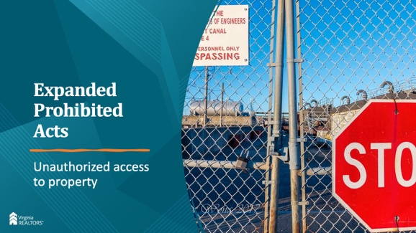 | Instructor: Another change is access to a property. Previously the regs stated that you couldn’t allow unsupervised access to a home without the owner’s authorization. Now the regs say that any unauthorized activity is prohibited, supervised or not. Any access to property without the owner’s authorization is a violation, regardless of whether you’re there.
Slide 9 |  | Instructor: The prohibition against performing any regulatory activities outside of your brokerage firm still exists, but now there is a very big exception. The new language says, "except for instances in which the licensee has an ownership interest in a property." This is significant for agents who own properties that they manage for themselves. But remember, brokers have the final say as to what is and is not allowed, so always check with your broker.
Slide 10 |  | Instructor: There were a few important changes to Section 280, Improper Financial Transactions and Dealings. First, section 280 now states that a salesperson can receive compensation for licensed activity from someone other than the salesperson’s broker IF there is prior written consent from the principal broker. This means, for example, that a settlement agent, could cut a check directly to a licensee if the principal broker has given prior written consent.
Slide 11 |  | Instructor: Another change to this section is the new section B. It now states: B. Actions constituting improper dealing include offering real property for sale or for lease without the knowledge and consent of the owner or the owner's authorized representative [without taking reasonable steps to verify identity], or on any terms other than those authorized by the owner or the owner's authorized representative. That means that you must now take reasonable steps to ensure that the person who hired you to sell their property is actually who they say they are. That means doing things like asking for in-person meetings, asking for multiple forms of identification, pushing back on suspicious data or documentation, and—perhaps most importantly—walking away from a potential listing if you are not comfortable.
Slide 12 |  | Questions?

