Slide 1 |  | Instructor: Introduction
Slide 2 | 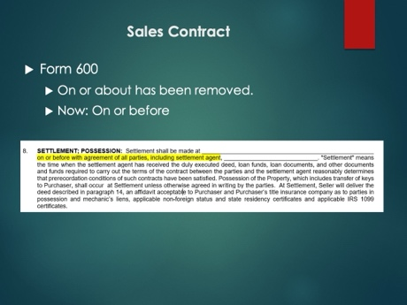 | Instructor:  The only change to the Residential Sales Contract, Form 600 has been on or about has now been replaced with on or before. Please note that before requires all parties to be ready to perform, this includes the settlement agent and any and all parties that are required for performance.
Slide 3 | 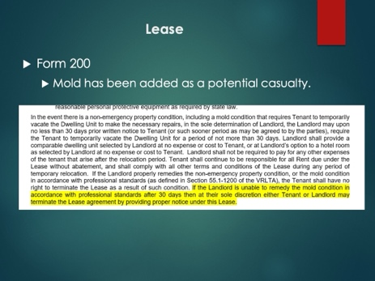 | Instructor:  If the Landlord is unable to remedy the mold condition as described in the VRLTA, either the Landlord or Tenant may terminate after 30 days by giving proper notice. Currently, both the Lease and the VRLTA is silent on what happens after the 30 days if Landlord cannot remedy the situation.
Slide 4 | 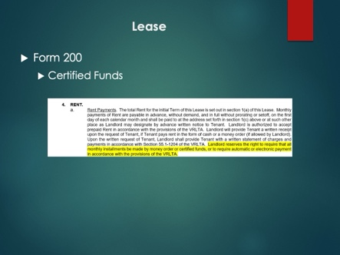 | Instructor:  Clarified that the owner may request certified funds as allowable by the VRLTA. Currently the Lease limits the Landlord’s ability to require certified funds to what is on the Lease; however, now the conditions where the Landlord can request certified funds has been expanded to the provisions of the VRLTA.
Slide 5 | 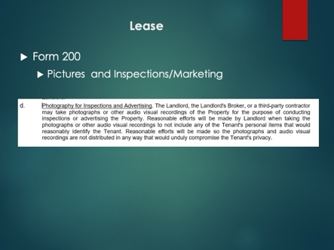 | Instructor:  Landlord (and Agent’s, third parties of Landlord) now has the explicit right in the Lease to take pictures or videos of the property for the purpose of inspections or advertising. Landlord needs to take reasonable efforts to not show Tenant’s property or otherwise anything that may be identifiable back to the Tenant when taking these pictures or videos.
Slide 6 | 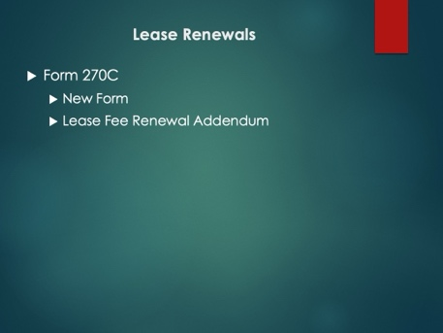 | Instructor:  The VRLTA was updated to provide:  § 55.1-1204.1. Fee disclosure statement.  A landlord shall provide, beginning on the first page of the written rental agreement, a description of any rent and fees to be charged to the tenant in addition to the periodic rent. Immediately above the list of fees, the written rental agreement shall state: No fee shall be collected unless it is listed below or incorporated into this agreement by way of a separate addendum after execution of this rental agreement.  This does NOT extend retroactively. However, if you would like to have all of the fees listed with any and all changes that have been historically done or any current changes, you can use this addendum with the Lease Renewal Addendum. It is a separate addendum from the Lease Renewal and if used BOTH should be signed by the Tenant.  https://law.lis.virginia.gov/vacode/title55.1/chapter12/section55.1-1204.1/
Slide 7 | 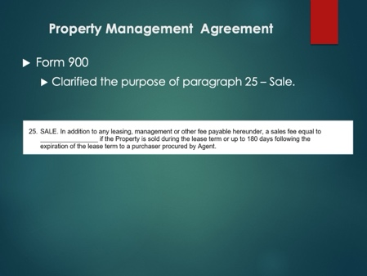 | Instructor:  If you procured the Tenant and the Owner sells the property to that Tenant during the lease agreement, then the fees in Paragraph 25 would apply.
Slide 8 | 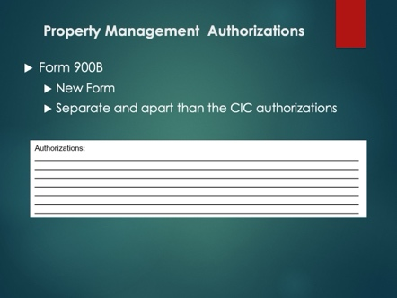 | Instructor:  This form is NOT the form you should use for any CIC authorizations. That one remains in the Property Management Agreement (last page). This form can be used as a one off when the Landlord provides the Agent with a legal authorization. The authorization must be memorialized here and both Landlord and Agent must sign it. This form is to save Agent’s the need to provide the entire PMA and other correspondence to a third party when an authorization does exist, instead the authorization can be memorialized here and provided to the third party.
Slide 9 | 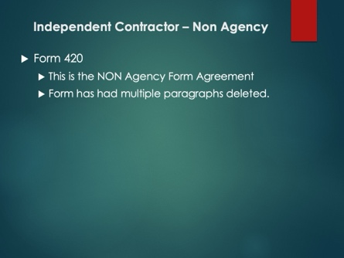 | Instructor:  Form 420 – No, this form is not between you and your Broker. This form is between the customer and the firm. Multiple paragraphs have been deleted to offer more variation and choice to between the customer and the firm. This form is for NON Agency, the duties prescribed by the statute are listed in the Form and knowledge thereof is required before using this form.  Please consult with your broker before using this form.
Slide 10 | 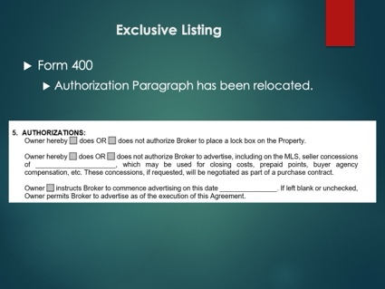 | Instructor:  Authorizations is now paragraph 5 and closer to the top. This should help the flow when meeting with a customer and sitting down to go over the form.
Slide 11 | 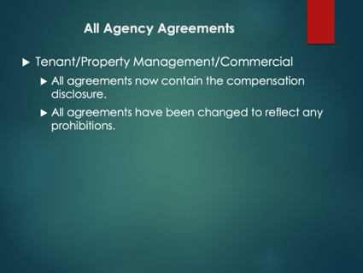 | Instructor:  All agreements now contain the compensation disclosure and any prohibitions from the NAR settlement. This was done whether required to by the settlement or not, now all agreements regardless of practice will contain these disclosures and prohibitions.  Lastly but not noted, several forms have had minor formatting changes which do not impact the practice.
Slide 12 |  | If you have any questions, please submit them through the Virginia REALTORS® Legal Hotline.

