Slide 1 | 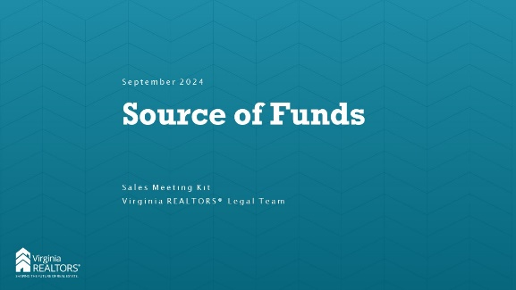
Slide 2 | 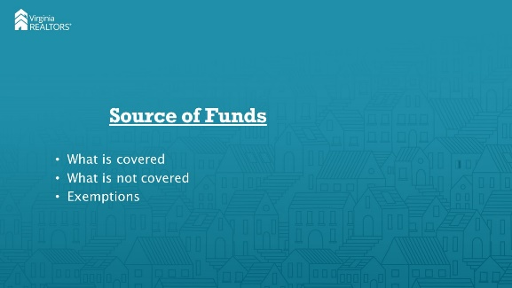 | [Instructor Notes]: In 2020, the General Assembly passed a bill adding source of funds to the list of protected classes under Virginia’s Fair Housing Law (Virginia Code Ann. § 36-96.3). The language prohibits refusing to rent or sell based on someone’s source of funds. The purpose behind the bill, according to the patron, was to protective prospective renters and buyers from discrimination if they intend to pay for housing using a Housing Choice Voucher. Later, DPOR provided guidance on what is and is not included in this language. Today we’ll go over that, along with an important exemption to the law.
Slide 3 | 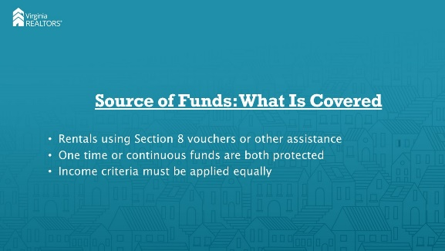 | [Instructor Notes]: The law prohibits housing providers from declining to rent properties to a prospective tenant because of the source of the money the tenant plans to use to pay their rent. For example, in most instances a provider cannot flat-out refuse to rent to a tenant who is using Section 8 vouchers to pay all or a portion of the rent. This is true whether the assistance is continuous (such as Section 8 vouchers) or one-time (like a one-time grant). Housing providers can still ask about income qualifications, but they must make sure they are basing their decisions on the tenant’s portion of rent, not total rent.
Slide 4 | 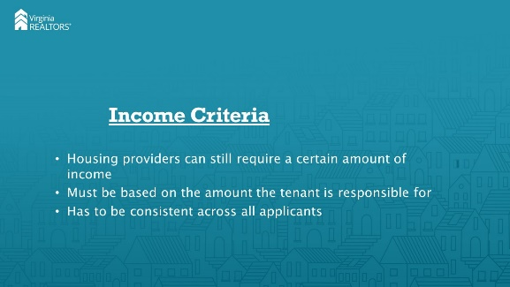 | [Instructor Notes]: DPOR’s guidance is clear that a housing provider can still check an applicant’s income and establish a certain threshold for eligibility. However, if the person receives a voucher or other support, the provider’s formula must take into account only the amount of rent the tenant is responsible for, not the total amount. For example, if monthly rent is $1,000 and the landlord’s income criteria is at least three times the monthly rent, the calculation must be done for the amount that the tenant him or herself is responsible for. So in that situation, if the tenant is receiving $750 a month through a voucher, they are only responsible for $250 a month in rent. That means the landlord’s income criteria is met if the tenant earns at least $750 a month ($250 in rent times 3).
Slide 5 | 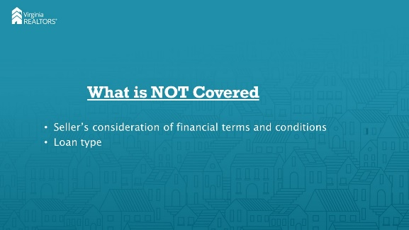 | [Instructor Notes]: DPOR guidance is very clear that the Source of Funds protection is not meant to prevent sellers from considering specific financial terms and conditions from prospective buyers. This includes the loan amount, loan program, or type of loan. A seller is still within her rights to pick an all-cash offer when there are other offers using USDA or VA loans, for instance.
Slide 6 | 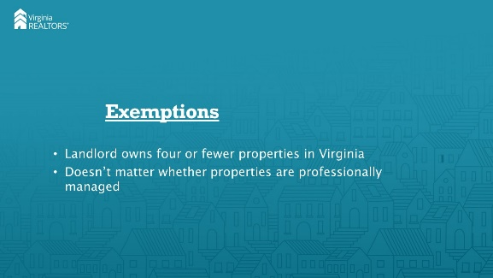 | [Instructor Notes]: In the property management context, there are a couple of important exemptions in the law. First, as with several other housing restrictions, the source of funds protection does not apply if the landlord “does not own more than four rental dwelling unites in the Commonwealth.” This means either sole ownership or at least a 10% ownership interest. Because the language specifies that the exemption is based on the landlord’s ownership, the exemption applies to these small landlords even if they have a licensed property manager overseeing the property.
Slide 7 | 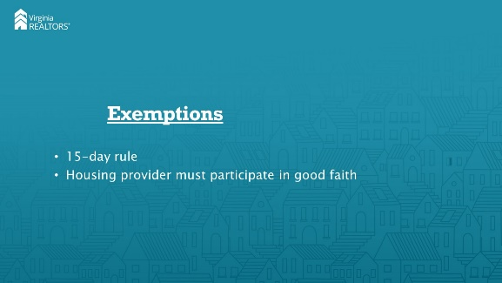 | [Instructor Notes]: The second exemption occurs if the source of funds is not approved within 15 days of the person’s submission for tenancy approval. This date is calculated from the date on which a complete package is delivered to the housing voucher administrator, and “approval” happens when the unit passes inspection as indicated on the inspection report. To qualify, the housing provider must participate in the inspection process in good faith (provide access to inspectors, deliver documentation in a timely manner, etc.).
Slide 8 | 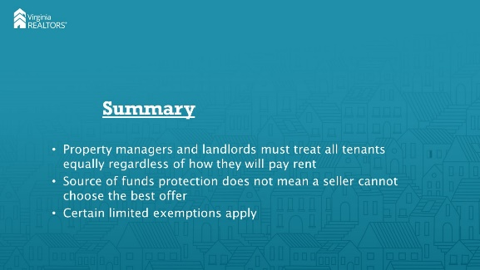 | [Instructor Notes]: In summary, the source of funds protection exists to ensure that all Virginians have equal access to housing, regardless of how they will be paying for that housing. Landlords must not discriminate against a tenant because they are using a housing voucher or other form of rent assistance. However, the protection is not meant to restrict sellers from choosing the offer (including loan type) that is best for them. Finally, there are a few exemptions to this protection for landlords, most notably that a landlord who owns four or fewer rental properties in Virginia may discriminate based on source of funds.
Slide 9 | 