Slide 1 | 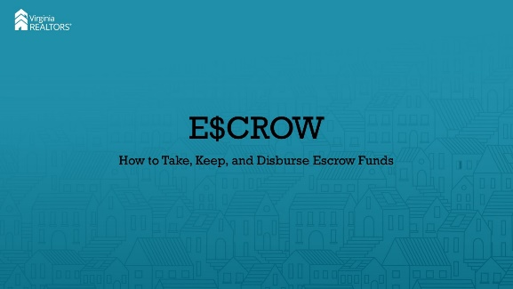
Slide 2 | 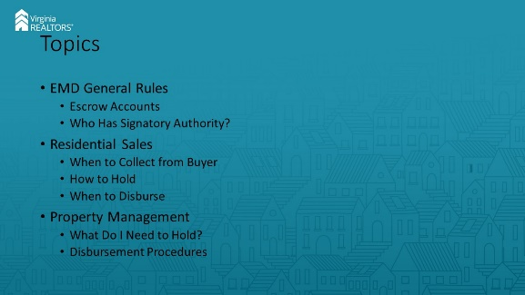
Slide 3 | 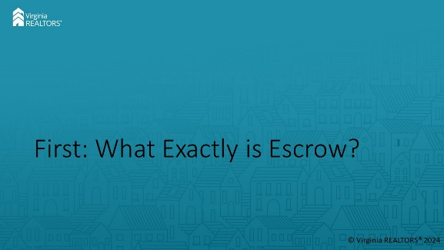 | [Instructor Notes]: It’s always good to start at the beginning, so let’s start by putting a definition to escrow funds. In simplest terms, funds held in escrow are those funds that you hold as a third party until a specified condition or conditions have taken place. In residential transactions, that’s when the transaction has closed and funds have moved to the seller. In property management, that’s when either rent that has been paid has come due or when, at the end of a tenancy, the security deposit either goes to the landlord for rent/damages/repairs or back to the tenants. It’s important to remember: money you hold in escrow IS NOT YOUR MONEY! You’re simply a caretaker. A heavily regulated caretaker.
Slide 4 | 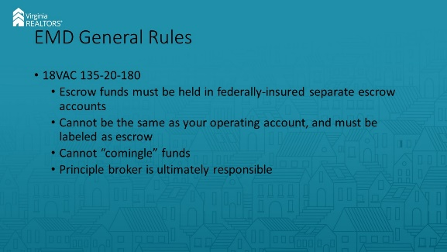 | [Instructor Notes]: This section of the regs provides you with a great starting point for your escrow journey. First, escrow funds have to be held in one or more “separate” accounts that are federally insured and specifically labeled as “escrow”. The money has to be separate from any operating accounts that your firm might have. If your operating funds and escrow funds are in the same account, you can be found to have “comingled” funds. That comingling is expressly prohibited by the regs. However, there could be situations where money that is in your escrow account will eventually belong to you. That’s totally fine, but those funds must be identified as such and must be paid to the firm whenever the funds come due to the licensee. Important note here—licensees cannot be paid directly from an escrow account. In that situation, the funds must be paid to the firm’s operating account, then passed on to the licensee.  Just like in most aspects of real estate, the ultimate responsibility for a firm escrow account belongs to the principal broker. That includes having signatory authority over the account. However, the principal broker can choose to give signatory authority to any other broker (or even licensee) if he or she chooses.
Slide 5 | 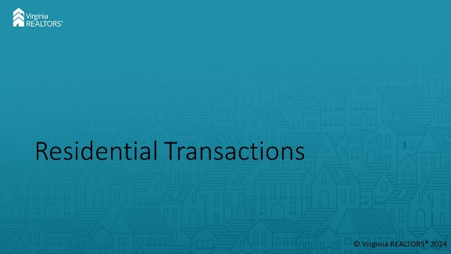
Slide 6 | 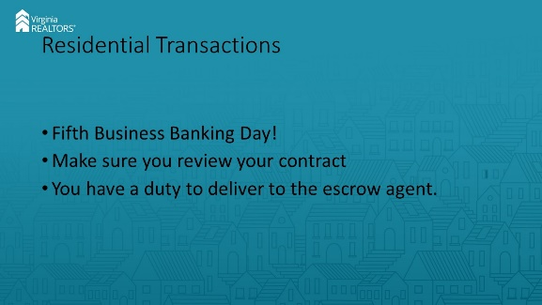 | [Instructor Notes]: The one phrase that you need to always remember when it comes to escrow is “Fifth business banking day”. The regulations state that you must deposit any EMDs that are to be held by the broker into the escrow account by the fifth business banking day following ratification of the contract, unless otherwise agreed to in writing. That means the contract is going to really govern your timeline. The VAR contract specifies that your five business-banking day period runs from the LATER of A) ratification or B) when you receive the EMD from the buyer. If the buyer gives you the EMD but the title company is going to be the escrow agent, the regulations say you still must deliver the EMD to that agent within five business banking days of when you receive it.
Slide 7 | 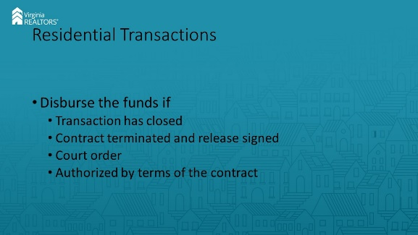 | [Instructor Notes]: Once you have the money in your account, there are only a few ways you can get rid of it. First, and hopefully most frequently, you will pay the EMD towards the purchase price at settlement by working with the settlement agent. Second, if the contract has terminated and both parties have signed a release, you can send the funds to the party that is entitled to receive them in the release. Third, if a court directs you to disburse the funds, you may do so. This can happen through a lawsuit or a proceeding that you initiate called interpleader (basically you just tell the court that you have money that doesn’t belong to you and ask them to direct you to disburse). Finally, as a real estate licensee, you can disburse the funds if the clear and unambiguous terms of the contract allow for it. The contract has to have clear instructions for where the money should go if you want to do this, and it’s important to note that it is not mandatory. You can always wait for one of the first three options to happen.
Slide 8 | 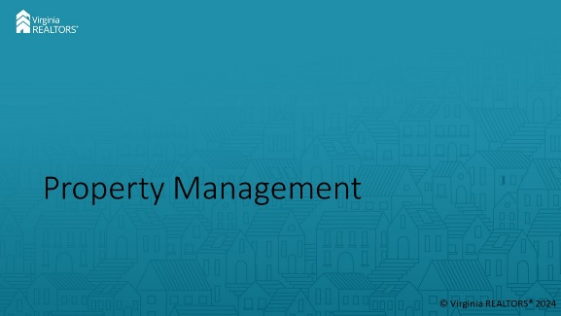
Slide 9 | 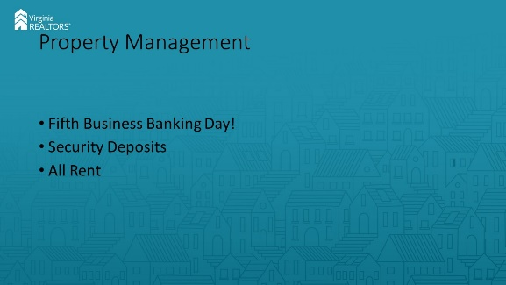 | [Instructor Notes]: Property management relies even more on escrow accounts. First, all security deposits (including pet deposits) must be placed in an escrow account by the fifth business banking day after receipt. The VRLTA describes various ways in which the security deposit can be used, but regardless it has to go into escrow. All rent must go into escrow as well, unless all of the principals to the transaction agree otherwise. This applies to prepaid rent as well as monthly rent. Once again, that magic phrase “fifth business banking day” applies.
Slide 10 | 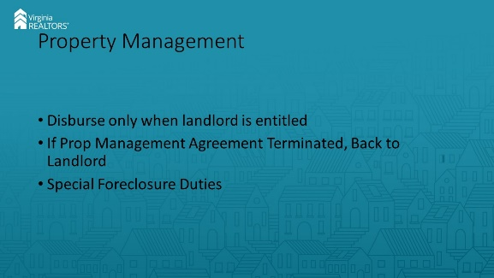 | [Instructor Notes]: The security deposit can’t be removed from the escrow account until the landlord has become entitled to receive it (either in whole or in part), unless the tenant agrees in writing. Under the VRLTA, the landlord is only entitled to receive funds from the security deposit after termination of the tenancy or when the tenant vacates the property, whichever comes first. For prepaid rent, the landlord can only get the portion to which he has become entitled. For example, if there are two months’ worth of prepaid rent, the landlord would become entitled to half of that amount on the first rent-due date. However, the other half would have to stay in escrow until the second rent-due date. If the property manager terminates the agreement, the PM can send the money held back to the landlord with notice to the tenant. If the property is foreclosed on while a tenant is there, the PM must send the money back to the tenant, not the landlord who is subject to the foreclosure process.
Slide 11 | 
Slide 12 | 