Slide 1 | 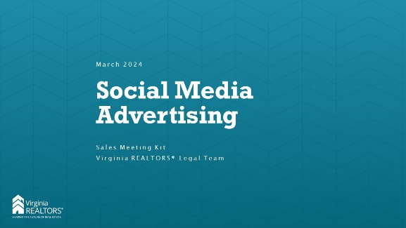
Slide 2 | 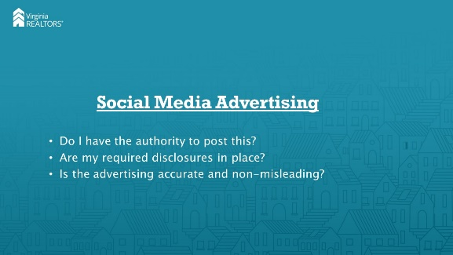 | [Instructor Notes]: These items are true for all advertising, but they are especially important when talking about social media advertising. This class will specifically focus on situations where your agents want to feature properties that are not their listings in social media advertisements.
Slide 3 | 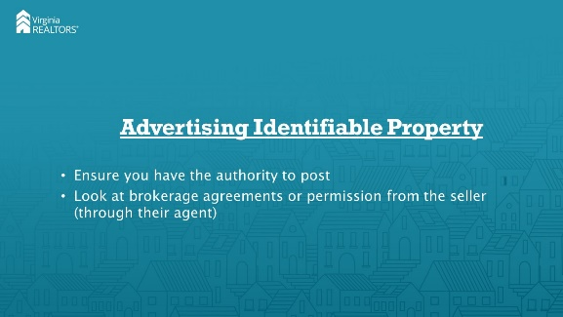 | [Instructor Notes]: The simplest example would be an agent who wants to advertise a property but does not yet have a listing agreement in place with the seller. Without that listing agreement, you have no authorization to advertise the property, and this would be a pretty cut-and-dried example of a violation. But in a situation where a buyer’s agent wants to celebrate a successful contract ratification, what do you need to do to make sure you’re safe?
Slide 4 | 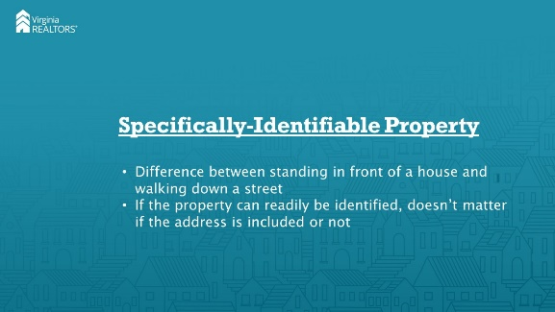 | [Instructor Notes]: The state regulations say that “failing to obtain the written consent of the seller [or] landlord . . . Prior to advertising a specific identifiable property” is a violation. Obviously posting the address of a property makes it “specifically-identifiable,” but even without that a house could be different or famous enough to make it specifically identifiable without things like an address. When in doubt, it’s always safest to get permission from the owner before posting.
Slide 5 | 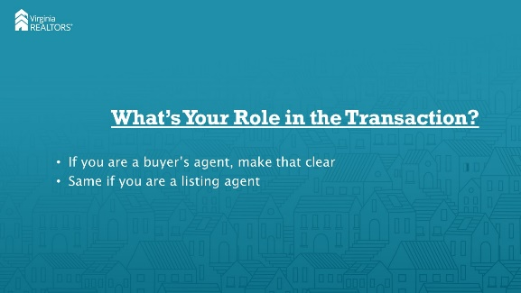 | [Instructor Notes]: The regs also state that you must identify the ype of services offered when you advertise a property. For example, posting a picture of a house that’s for sale might create the impression that you are the listing agent. If you are in fact the buyer’s agent, you need to clearly state that somewhere on the advertisement. Likewise, if you are the listing agent, you want to make sure that consumers are aware when contacting you that you are not (necessarily) there to represent them in purchasing the house.
Slide 6 | 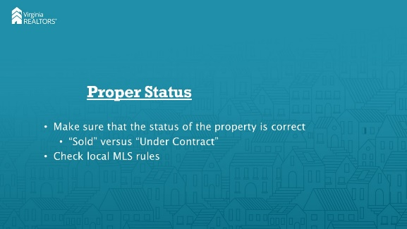 | [Instructor Notes]: You’ll also want to ensure that the status of your advertising is accurate. For example, if your clients are under contract on a house but have not yet closed, it would be inaccurate to say that the house has been “sold.” You might want to check your local MLS rules for the particular way to refer to the different statuses present in that MLS.
Slide 7 | 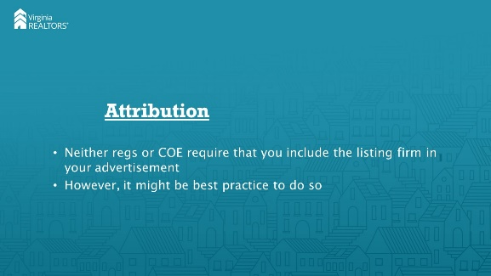 | [Instructor Notes]: While the regs and COE do not expressly require you to attribute the photos to the listing firm or agent, if the agent expressly asks you to credit the firm (or the agent) then you should do so. And in general, while it’s not required, it might be best practice to mention the listing firm regardless.
Slide 8 | 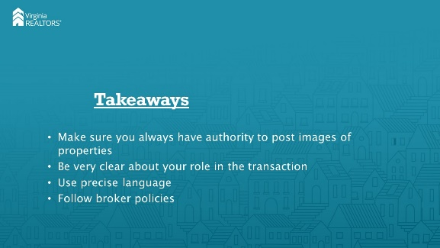 | [Instructor Notes]: So to be safe, as a buyer agent you should always make sure that you get permission from the seller/owner (through their agent if they’re represented) before you post a property that isn’t one of your listings. Be clear in your language regarding your role in the transaction (buyer agent v. listing agent). And use precise language; don’t say “sold” when you really mean “under contract”. And, last but certainly not least, make sure that you follow any policies or procedures that your broker may have in place regarding advertising.
Slide 9 | 