Slide 1 |  | Today we will discuss who does, and who does not, have the right to access rental properties.
Slide 2 | 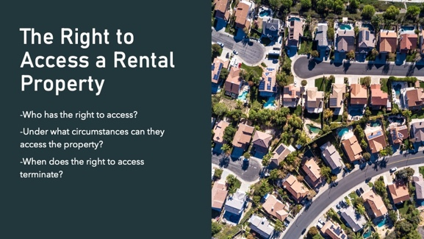 | Read slide
Slide 3 |  | First, to state the obvious, any and all tenants who are parties to the lease agreement have the absolute right to access the rental property. The right of the tenant or tenants to access the rental property is only terminated pursuant to a court order or when the lease agreement concludes.  Besides tenants, authorized occupants who are named in the lease agreement also have the absolute right to access the rental property – a right that is likewise only terminated pursuant to a court order or at the conclusion of the lease term.
Slide 4 |  | Guests of any tenant or authorized occupant may also access the unit with the permission of a tenant or occupant, but the duration a guest can access the unit is limited. How limited will vary depending on the terms of the lease agreement. The Virginia REALTORS standard lease allows guests to stay in the unit for up to seven consecutive days, or 14 days in a calendar month. Once those timeframes have elapsed, the guest becomes an unauthorized occupant.
Slide 5 | 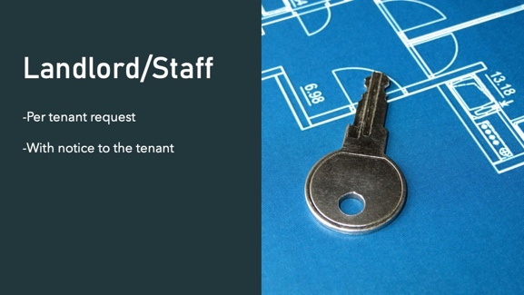 | Property management staff and/or the landlord have the right to access the rental property, either at the request of the tenant, or with proper notice given to the tenant. What constitutes proper notice? That is going to depend on the reason access to the property is needed.  The Virginia REALTORS standard lease requires the landlord give the tenant at least 24 hours notice of application of pesticide in the property, and 72 hours notice of any routine maintenance to be performed. Other timeframes, such as notice for showing the unit to prospective tenants, buyers, contractors, etc., require “reasonable” notice and coordination with the tenant.
Slide 6 |  | If purpose of accessing the rental property is to take pictures to use in advertisements for re-renting the unit after the current tenant moves out, or to sell the unit, the current tenant must give permission. Photographs of the tenant’s belongings constitute “tenant records” so the rules around confidentiality apply.
Slide 7 |  | First, any guests who have been banned from the property by the landlord may not access the rental property, even at the invitation of a tenant or authorized occupant. The landlord has the right to prohibit individuals from the property who the landlord deems to either be a threat to health and safety, or otherwise disruptive to property staff or fellow tenants.  Additionally, tenants or authorized occupants who have been barred from the property pursuant to a court order such as a protective order may not access the rental property. The barring of a tenant or authorized occupant from the property can only be done via court order; the landlord does not have the authority to unilaterally bar someone from the property who is named on the lease agreement.
Slide 8 |  | Guarantors take on the full liability of the rent payment obligation, and any other fees, pursuant to the lease agreement. In other words, if a tenant stops paying rent, the guarantor can be sued for the entirety of any amount owed. Additionally, just as a matter of common practice, a guarantor is often a family member of the tenant, not just some stranger seeking access to the rental unit.  That being said, guaranteeing a lease does NOT make the guarantor a tenant or an authorized occupant. A guarantor can certainly be a guest of a tenant or occupant without any problem, but the guarantor does not have the right to access the property without the permission of the tenant.
Slide 9 |  | Questions?
Slide 10 |  | Read slide.
Slide 11 |  | Read slide.
Slide 12 |  | Read slide.
Slide 13 |  | Read slide.
Slide 14 |  | Read slide.  This means salary or hourly!
Slide 15 |  | Any questions?

