Slide 1 | 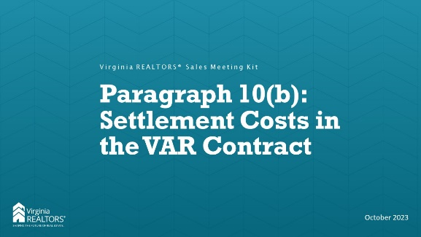
Slide 2 | 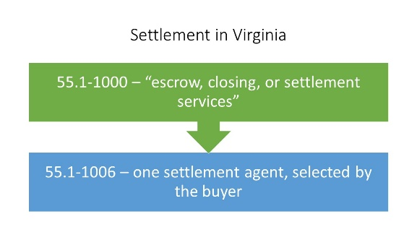 | Instructor: In Virginia, there is only one settlement agent for a transaction, and that agent is selected by the buyer. The code lists 16 things that are considered “escrow, closing, or settlement services” that must be done by the SA (or their designee). Basically this is everything but preparing the deed and paying recordation taxes. A licensed attorney can be a settlement agent, or a lay settlement agent (non-attorney) can handle the closing. An attorney would still have to draft the deed and any POA or affidavit required. Some companies have both lay settlement agents and attorneys, while others are separate. The seller can choose to have an attorney represent them, but they cannot engage a lay settlement company to work with them.  List of escrow, closing, or settlement services: These services include placing orders for title insurance, receiving and issuing receipts for money received from the parties, ordering loan checks and payoffs, ordering surveys and inspections, preparing settlement statements or closing disclosures, determining that all closing documents conform to the parties' contract requirements, setting the closing appointment, following up with the parties to ensure that the transaction progresses to closing, ascertaining that the lenders' instructions have been satisfied, conducting a closing conference at which the documents are executed, receiving and disbursing funds, completing form documents and instruments selected by and in accordance with instructions of the parties to the transaction, handling or arranging for the recording of documents, sending recorded documents to the lender, sending the recorded deed and the title policy to the buyer, and reporting federal income tax information for the real estate sale to the Internal Revenue Service.
Slide 3 | 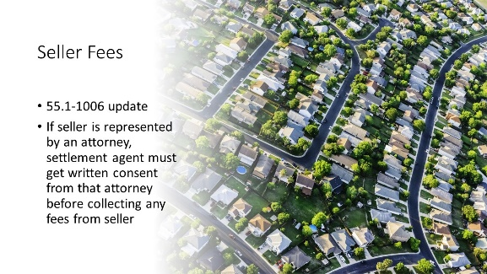 | INSTRUCTOR: This was added to 55.1-1006 in the last General Assembly session. This is pretty basic, but it states that a settlement agent may not collect fees from a represented seller without written consent from that attorney. Importantly the language specifies that the fees are not just those from the settlement agent, but also from “its subsidiaries, affiliates, or subcontractors.” That includes title abstractors or any other company associated with the settlement agent.
Slide 4 | 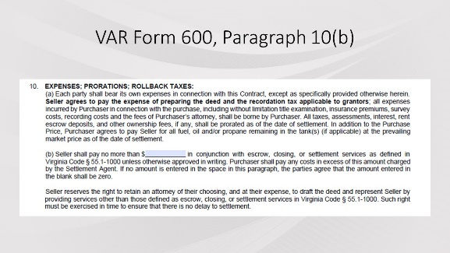 | INSTRUCTOR: The state Board of Insurance issued a letter in February of 2022 clarifying its position that there can be no “split” settlement in Virginia, where a seller has a lay settlement agent (i.e., not an attorney) representing them at closing. It reinforced the law that there is only one settlement agent, picked by the buyer, for a transaction. That settlement agent represents not the buyer, but the transaction itself. After that letter came out, VAR heard examples of settlement agents charging sellers very significant fees as part of the transaction. To establish expectations at the beginning of the transaction, the Standard Forms committee added paragraph 10(b) to the contract. This allowed all parties to know at the very outset exactly what a seller would be willing to pay for settlement services as part of the transaction.
Slide 5 |  | INSTRUCTOR: Again, 10(b) is only meant to make sure all parties are on the same page regarding settlement fees and who will be paying them. A seller might agree to pay higher fees in a buyer’s market as a bargaining chip, or they may leave it blank and ensure that they pay $0 in a seller’s market. The paragraph also restates the law that a seller has the absolute right to hire an attorney (but not a lay settlement agent) to represent them in the settlement.
Slide 6 | 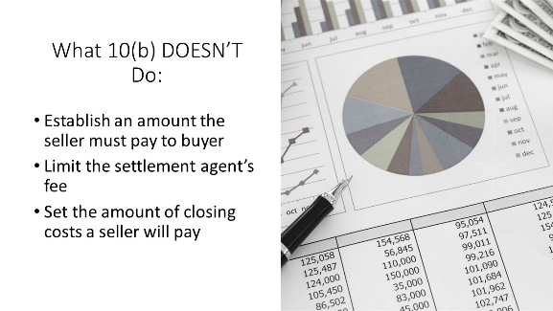 | Instructor: This paragraph does not mean that the seller is obligated to pay anything to the buyer! For example, if a seller puts $250 in the blank and the settlement agent only charges the seller $150 for settlement-related services, the seller does NOT owe the buyer the other $100. This only acts as a cap on the amount the seller could pay.  This also doesn’t limit the fee that a settlement agent can charge for a transaction. The settlement agent may still charge whatever is reasonable and customary for settlement services, but the seller can only be responsible for paying up to the amount listed in 10(b). As the buyer has the right to choose the settlement agent, the buyer will pay the settlement costs. Importantly, this also does not prevent the settlement agent from charging the seller for something like deed preparation. That is not specifically listed as an “escrow, closing, or settlement service” in the code, so if the settlement agent is providing that service for the seller the settlement agent can charge a fee without regard to paragraph 10(b).  This is also not the place to establish closing cost help that a seller is willing to give to the buyer. For example, if a seller is willing to pay $3,000 in closing costs to the buyer, you would not put $3,000 in Paragraph 10(b). That information would go in Paragraph 3(e) of the contract for seller concessions/closing costs. Again, this paragraph just establishes the maximum amount the settlement agent can charge a seller for certain specified services.
Slide 7 |  | Instructor: As the market shifts, look to paragraph 10(b) as another point of negotiation. For sellers, make sure they know that they can offer to pay settlement fees but if they leave the field blank, they will not pay anything for “escrow, closing, or settlement services.” Sellers can hire an attorney at any point during the transaction to represent them, and if they have an attorney the settlement agent can’t charge them any fees (regardless of what’s in 10(b) without written consent of the attorney. For buyers, make sure they know that they are responsible for any fees above whatever the seller has put into that blank. Up-front discussions with settlement agents regarding charges is important to setting expectations for the amount that will be due at the closing table.
Slide 8 | 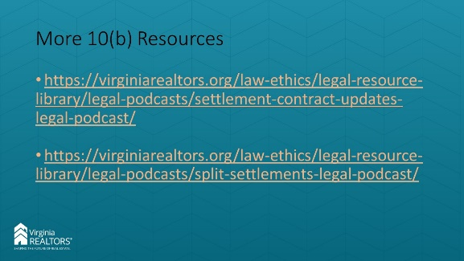 | Instructor: You can find two podcasts that we created on this topic at these links if you would like more information. And, as always, you can contact the Legal Hotline for any questions you might have.
Slide 9 | 