Slide 1
Slide 2 | 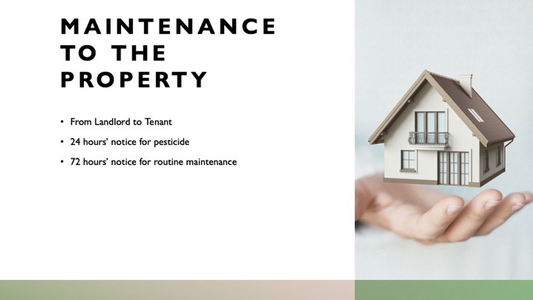 | How much notice the tenant is entitled to for performance of routine maintenance will be governed by the lease. The Virginia REALTORS® standard lease requires the landlord give the tenant at least 24 hours notice of application of pesticide in the property, and 72 hours notice of any routine maintenance to be performed. The landlord is not required to give notice or adhere to these timeframes if the maintenance performed is requested by the tenant.
Slide 3 |  | Notice required to show the property to prospective tenants, buyers, contractors, etc., is also going to be governed by the terms of the lease. The Virginia REALTORS® standard lease requires “reasonable” notice and coordination with the tenant. The tenant is likewise required to act reasonably in finding a suitable time in which to show the property.
Slide 4 |  | During any inspection, the landlord may take photographs of the interior of the property. However, those photographs become “tenant records” and are therefore required to be kept confidential. The landlord may, however, give notice to the tenant of the desire to use photographs of the property for advertising or other similar purposes, and request tenant’s consent. Tenant is not obligated to give such consent.
Slide 5 | 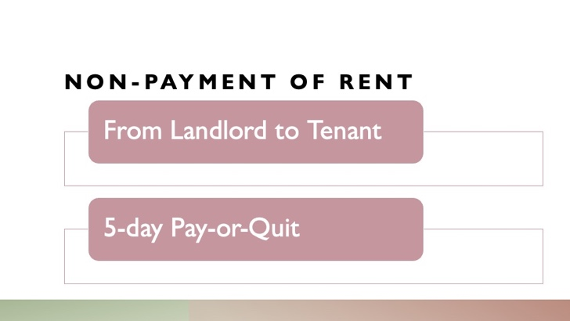 | Notice informs tenant of the amount due. All amounts due to landlord are considered “rent” including and fees or utilities that are owed by the tenant to the landlord. If tenant does not pay amount due in full within five days, landlord may begin unlawful detainer proceedings.
Slide 6 | 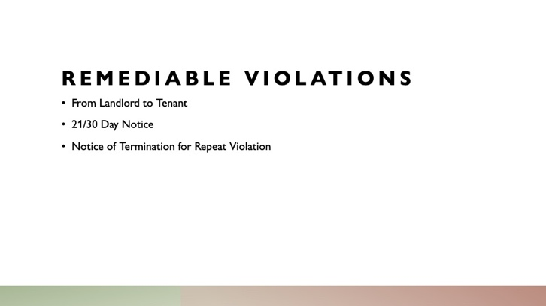 | Issued when a tenant has breached some provision of the lease, but the breach can be remedied. For example, allowing an unauthorized occupant to stay in the property or parking in the incorrect parking spot would be remediable violations. Tenant would have 21 days to correct the violation. If after 30 days the violation has not been corrected, the landlord can begin unlawful detainer proceedings.  If the tenant repeats the same violation again, the landlord can serve a 30-day notice of termination due to the repeat violation.
Slide 7 | 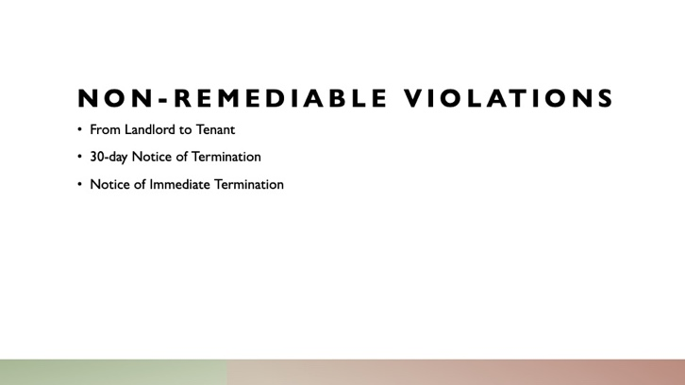 | 30-day Notice of Termination explaining the nature of the breach is issued when a tenant has breached a provision of the lease that cannot be rectified. If the breach involves a criminal drug activity or a threat to the health and safety of others, landlord may serve a notice of immediate termination.
Slide 8 |  | Tenant may, at any time, submit a notice of maintenance needed on the property. The landlord is required to make diligent efforts to perform the maintenance within a reasonable period of time. How long “reasonable” is will vary from case to case. If the heat goes out in the winter, the landlord is obligated work to repair the issue much more quickly than if, say, a doorknob to an interior door broke. There is a rebuttable presumption that if the landlord takes longer than 30 days to act on a maintenance request, the landlord has acted unreasonably, in which case the tenant will have grounds to file a tenant’s assertion.
Slide 9 |  | Either party may give notice to the other of their intent to not renew the lease. The lease itself will govern how much notice is required. For month-to-month leases, 30 days’ notice is typically required to non-renew, while 60 days’ notice is typically required for lease terms of several months or longer.

