Slide 1 | 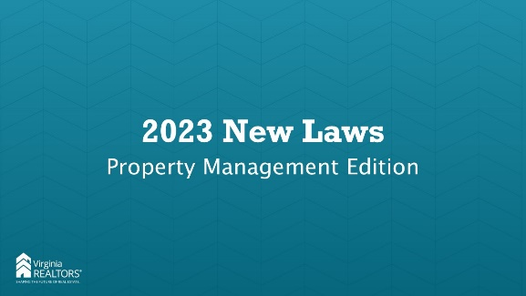 | Unless otherwise noted, all bills are effective on July 1, 2023.
Slide 2 | 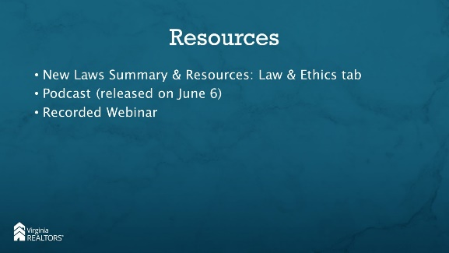 | Instructor: Here are some additional new laws resources that VAR has made available to you. You can access all of these by going to virginiarealtors.org.
Slide 3 |  | Like many years, we have several bills related to property management, landlord tenant law, and the Virginia Residential Landlord Tenant Act (VRLTA).
Slide 4 | 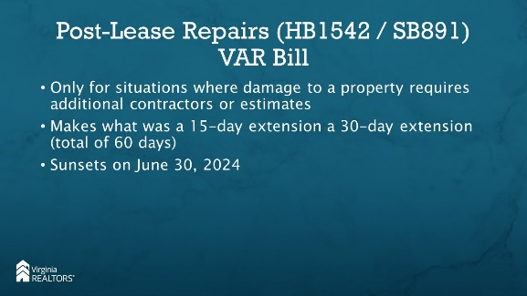 | Instructor: This is a temporary provision that allows an additional 15 days for landlords to obtain estimates and perform repairs after the end of the lease. Typically landlords have 45 days from the end of the lease term to provide tenant with an itemized list of damages, but the VRLTA allows an additional 15 days in the event that the damages require a contractor (for a total of 60 days). Because of the pandemic, it has been harder to get contractors and supplies, so the GA is giving a TEMPORARY extension of an additional 15 days (total of 75). This will end on June 30, 2024.
Slide 5 | 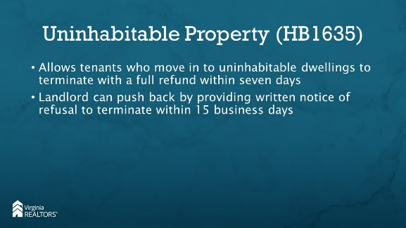 | Instructor: If a tenant goes to move into a property and there is a condition that constitutes a fire hazard or serious threat to the life, health, or safety of tenants or occupants, the tenant is entitled to terminate the rental agreement and receive a full refund of all deposits and rent paid to the landlord, as long as the tenant provides the landlord with written notice of their intent to terminate within 7 days of the date of possession.  Conditions that constitute a fire hazard of serious threat to the life, health, or safety of tenants or occupants includes:  - Rodent infestation  - Lack of heat, hot or cold running water, electricity, or adequate sewage disposal facilities  If the tenant provides notice to the landlord, the landlord can assert that the tenant is unjustified in his termination by providing written notice to the tenant of his refusal to accept the tenant’s termination notice along with the reasons for such refusal within 15 BUSINESS days.
Slide 6 | 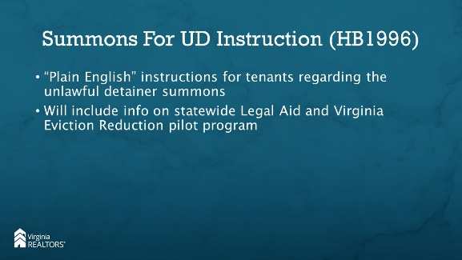 | Instructor: a document is being developed that provides “plain English” instructions that explain to defendants how to interpret the summons for unlawful detainer. This form will also include information on the statewide legal aid and Virginia Eviction Reduction Pilot program.
Slide 7 | 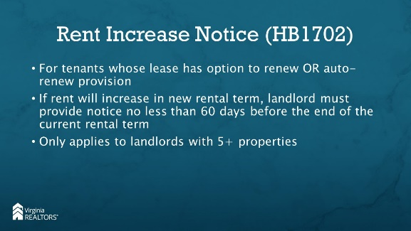 | Instructor: For landlords who owns more than four properties (or more than a 10% interest in more than 4 units) in Virginia, they will now be required to provide written notice to any tenant who has the option to renew a lease or whose lease contains an automatic renewal provision of any increase in rent during the subsequent rental agreement term. This notice must be provided no less than 60 days before the end of the rental term.  If you are using the Virginia REALTORS lease (Form 200), paragraph 1.j. allows for you to fill in any number of days for notice to terminate/renew. That is still fine, so long as the rent will not be increasing. Let’s say you’ve written 30 days in that field, but the owner wants to increase rent. You must give notice 60 days before the renewal, even though the lease only says 30 days notice.
Slide 8 | 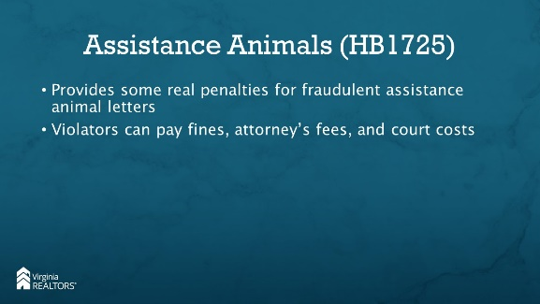 | Instructor: This bill makes it a violation of the Virginia Consumer Protection Act for a person with a “therapeutic relationship” to provide fraudulent supporting documentation of an individual’s disability or disability related need for an assistance animal.  The Virginia Consumer Protection Act allows for “any person who suffers loss as the result of a violation of this chapter” and allows for actual damages or $500, whichever is greater. If the violation was willful, damages may be increased to 3 times actual damages or $1,000 whichever is greater. Additionally, the person can be awarded reasonable attorneys’ fees and court costs.  This is not a perfect solution for stopping people who provide documentation for assistance animals as a way to get around pet restrictions, rent or deposits, but it is something.
Slide 9 | 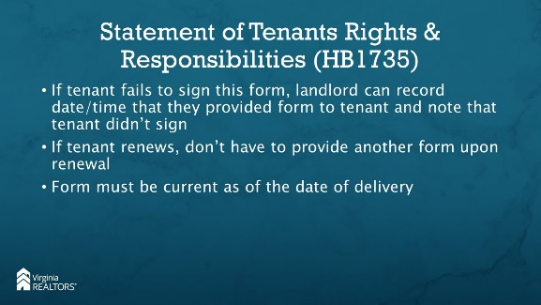 | Instructor: Some judges are refusing to proceed with unlawful detainer actions if the tenant hasn’t signed the Statement of Tenants Rights and Responsibilities – which tenants are refusing to sign as a way to prevent eviction when they are at that point.  It was never intended that if the landlord provided the Statement of Tenants Rights and Responsibilities, but either forgot or could not get the tenant to sign the document that they would never be able to file for Unlawful Detainer. Now the law says that if the tenant fails to sign the form, the landlord shall record the date on which they provided the form to the tenant and the fact that the tenant failed to sign the form.  It also states that subsequent to the effective date of the tenancy, a landlord may, but is not required to, provide the tenant with and allow the tenant the opportunity to sign the form – so essentially, at renewal, you are not obligated to provide the form again.  Finally, the law clarifies that the form must be current as of the date of delivery – not current when the unlawful detainer action begins.  If you are encountering judges after July 1 that are requiring Statement of Tenants Rights and Responsibilities that are signed by tenants, please let VAR know.
Slide 10 | 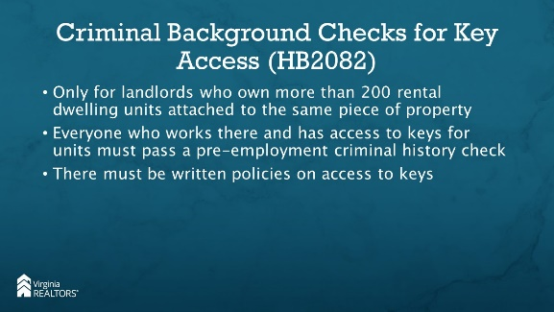 | Instructor: It’s unlikely this will apply to any of you, but we wanted to include it just in case. This law only applies to a landlord who owns more than 200 rental dwelling units that are attached to the same piece of real property – so essentially a rental community with 200+ units in the same community.  Any landlord for a large apartment community (200+ units) must have  - a policy requiring any applicant for employment in any position that will have access to keys for each rental dwelling unit to be subject to a pre-employment criminal history record check and  - Written policies and procedures regarding the storage, issuance, return, security of, access to, usage, and deactivation of keys and electronic key codes.  Essentially – if someone will have access to keys that would allow them to enter units, the landlord must do a criminal background check and then have policies around who can access the keys.
Slide 11 | 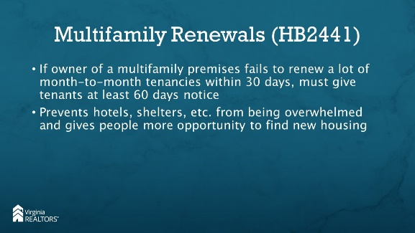 | Instructor: If you manage multifamily rental properties, there are new requirements in place if the owner will not be renewing a lot of leases in a short period of time. This bill came up after one apartment community that provided a large percentage of the housing stock in an area terminated all of the leases within a few months creating a housing crisis because all of the hotels were full and there were no other rental units available to house the displaced tenants.  Now, if an owner of a multifamily premises fails to renew the greater of either:  - 20 or more month-to month OR  - 50% of the month-to-month  Tenancies within a consecutive 30-day period in the same premises, they must serve written notice on tenants at least 60 days prior to allowing the tenancy to expire.  This does not apply when the termination when the tenant has failed to pay rent.  What does this mean? If you are going to terminate 20+ or more than ½ of the month to month leases in a community within a 30 day period, you would need to give those tenants extra notice to find somewhere to live so that the housing market isn’t flooded by a large number of tenants looking for housing all at once.
Slide 12 | 