Slide 1 |  | Instructor:  Introduction  All the laws in this presentation are effective July 1st, 2023.
Slide 2 | 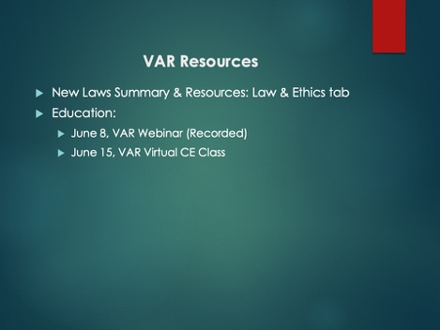 | Instructor:  Links to the actual bills, will be up on VAR’s website under the Law and Ethics tab. VAR will also release a podcast; for those brokers out there; and offering more education.  If you want to attend and also share with your colleagues:  Thursday, June 8, we will have a webinar on New Laws that will be recorded and available for replay in the Learning Center  Thursday, June 15 we will teach this same class virtually again as well.  This is in addition to any classes your local associations may be offering.
Slide 3 | 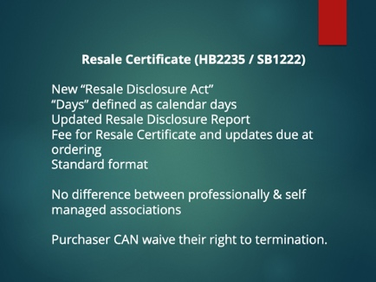 | Instructor: Common Interest Communities and the Resale Certificate.  These bills were part of the Virginia REALTORS® Legislative Agenda.  This law goes into effect on July 1 and contains a provision that specifies that it does not apply to any contracts ratified prior to July 1. If you have a contract that is ratified on or before June 30, you are still under the current law. If you have a contract that is ratified on July 1, you will be under the new law. If you have a seller who has already requested the disclosure packet know that if they don’t have a ratified contract on June 30, they will have to order a new packet that complies with the current law.  The first thing these bills do is take all language regarding resale certificates or disclosure packets and puts them into one section. The language is no longer in the POA Act and Condo Act separately – the requirements are combined into one new section that is chapter 23.1 of Title 55.1. This change just means that if you were someone that would go looking for requirements in the law itself, you’re going to be going to a different section to look for the information regarding resale disclosures or certificates. As part of this, you’ll also see technical changes throughout the POA and Condo acts where the documents the seller gives the buyer are now all called “resale certificates” – no more “disclosure packets.”  While it’s not “new”, the law has been updated to clarify that “days” throughout the law means calendar days, not business days.  Now there will be a standard format and order for the documents provided by the association. There will be essentially a table of contents that the association will mark which items apply to them and then include those relevant items in a consistent order. This will make it much easier for your clients to quickly find information related to the various items listed in the law.  The law now makes it the default that fees are collected upon ordering, but it does say “unless provided otherwise by the association” so in theory, an association could still wait until settlement to collect the fees.  The law gets rid of the distinction between professionally and self managed associations.  The new law also allows the parties to negotiate the buyer’s right to terminate after receiving the resale disclosure. This means that the buyer can waive their right to terminate entirely or the parties can agree to an extension of the right to terminate period. While the buyer can waive the right to terminate, the law does not allow the parties to waive the seller’s obligation to provide the packet to the buyer, it also does not allow the buyer to waive receipt.
Slide 4 | 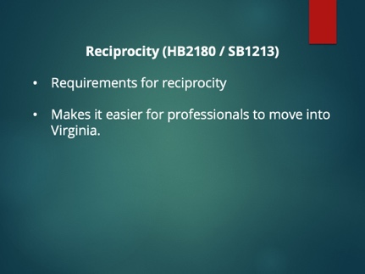 | Instructor: These bills are general reciprocity bills.  The bills start by saying that if someone who has a license in another state applies for a Virginia license, DPOR must recognize the license as long as certain requirements are met.  The person must:  - Have a current, valid license in a similar scope of practice;  - Have held the license for at least 3 years,  - Have passed an exam and meet certain standards related to education, training or experience;  - Not have any pending or unresolved complaints and is in good standing;  - Not have a disqualifying criminal record  - Not have been disciplined, except if the discipline was only a fine and no harm to the health or economic wellbeing of the public was involved  - And pay applicable fees.  If another state that does not use a professional or occupational license or government certification to regulate a profession or occupation, but the Commonwealth does, DPOR must recognize the experience of the individual from their time in the other state so long as they have worked for at least three years, passed any exam required by the applicant’s board, and there are no discipline or criminal background issues, and the person pays the fees.  DPOR boards are allowed to require a “jurisprudential examination specific to relevant state laws and administrative rules” if such exam is required of other applicants.  Now if the applicant doesn’t meet all these requirements – let’s say they don’t have 3 years experience – that just means they have to go through the regular application process like a new licensee. The reciprocity is intended to make it easier for people who are licensed in other states to get licensed in Virginia. Which means that hopefully we’ll start to see more providers in fields where things have been tight, like appraisers.
Slide 5 | 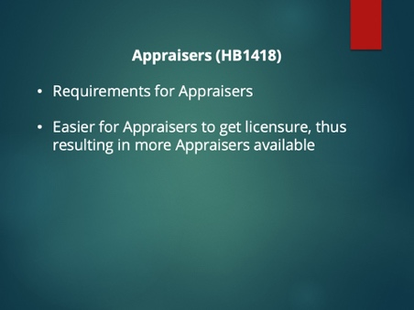 | Instructor:  Currently, individuals applying for an appraisers license must verify their experience in the field of real estate appraisal.  This means that anyone who wants to become an appraiser must find someone that they can apprentice with, which is not always easy to do. Now, the Real Estate Appraiser Board must accept evidence that the applicant has successfully completed the Licensed or Certified Residential Practical Applications of Real Estate Appraisal (“PAREA”) training program to satisfy the experience requirement.  If an applicant has completed the Licensed Residential PAREA program, they receive the equivalent of 1,000 hours towards the experience requirement – this is 100% of what is required of licensed real estate appraisers, 67% of what is required of certified residential real estate appraisers, and 33% of what is required of certified general real estate appraisers.  If an applicant has completed the Certified Residential PAREA program, they receive the equivalent of 1,500 hours towards the experience requirement – this is 100% of what is required of licensed or certified real estate appraisers, and 50% of what is required of certified general real estate appraisers.  The goal is to allow individuals who are not able to find someone to apprentice under to still be able to enter the real estate appraisal industry. This should help with both diversity and coverage in areas with fewer appraisers.
Slide 6 | 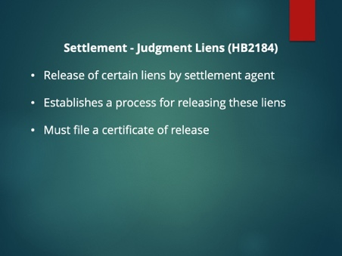 | Instructor:  This first bill allows a settlement agent to release a judgment lien on a property in certain circumstances. Essentially, if the settlement agent tries to obtain payoff information from the lien creditor and either can’t locate the lien creditor or does not receive a response, then the settlement agent can release the lien on the property.  So, for example, if the owner has a judgement lien on the property for a Circuit City credit card, but there’s no way to pay it off anymore, after going through certain steps, the settlement agent can remove that lien and clear the property. I do want to note that this only releases the judgment lien on the property that is being sold and not on any other real property owned by the judgement debtor.  If:  - the settlement agent has made a written request for a payoff amount from the lien creditor and his counsel of record;  - the lien creditor doesn’t respond within 15 days or can’t be found after the settlement agent attempts to notify following provisions in the law;  - The settlement agent has delivered or attempted to deliver notice of intent to release and the lien creditor has not responded; and  - The owner of the property attests in an affidavit that the owner has paid all or a portion of the judgement but in good faith does not have knowledge of the balance or the owner is not the judgement debtor and has no knowledge of the balance.  Then the settlement agent can file a certificate of release with the clerk of court in the jurisdiction in which the property is located, which shall be a release of a judgement lien on the property.
Slide 7 | 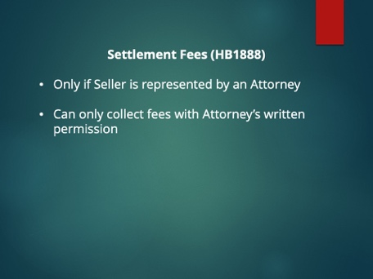 | Instructor:  One sentence was added to the sections of the law dealing with choice of settlement agent and the required disclosure that goes in contracts regarding choice of settlement agents.  “The settlement agent may not collect any fees from a represented seller payable to the settlement agent or its subsidiaries, affiliates, or subcontractors without first obtaining the written consent of the seller’s counsel.”  What does this mean? If the seller has hired an attorney to represent them in a transaction, the settlement agent cannot charge that seller any fees without first getting written permission from the seller’s attorney. If the seller is NOT represented by an attorney, this does not apply.
Slide 8 | 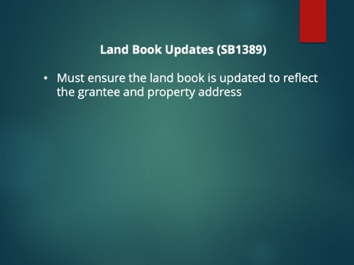 | Instructor:  When a commissioner of revenue for a locality receives the recordation receipt from the clerk of court, they must ensure that the land book is updated to reflect the grantee and property address, or other address included in the document, for delivery of future tax bills.
Slide 9 | 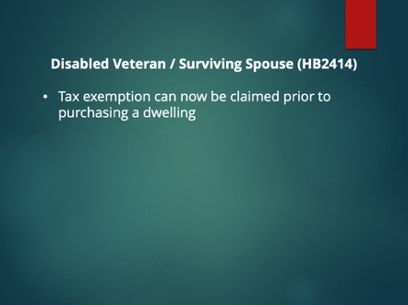 | Instructor:  Currently, a disabled veteran or surviving spouse may claim a tax exemption on real property by applying with the locality once they have purchased a property. This bill allows the veteran or surviving spouse to claim the exemption PRIOR to purchasing a qualifying dwelling by filing the required documentation along with “valid documentation of the purchase agreement for the qualifying dwelling.” Within 20 business days of receiving the documentation, the locality’s commissioner of the revenue must process the application and send the veteran a letter stating whether the application is approved or denied. If the application is approved, the letter will also include the amount of the tax exemption.  Essentially, this allows a disabled veteran or surviving spouse to go through the approval process while they are under contract so they will know how much they will owe in taxes before settlement.
Slide 10 | 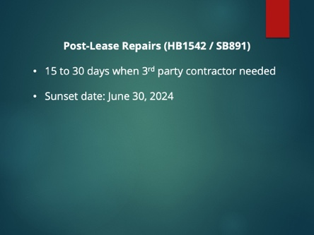 | Instructor:  This is a temporary provision that will allows an additional 15 days for landlords to obtain estimates and perform repairs after the end of the lease, for a total of 30 days. Because of the pandemic, it has been harder to get contractors and supplies. This will end automatically on June 30, 2024.
Slide 11 | 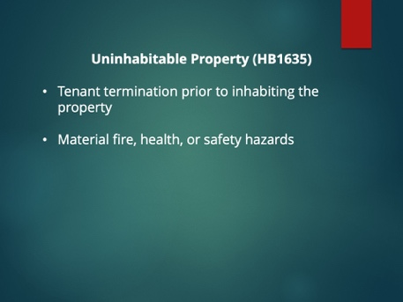 | Instructor:  If a tenant goes to move into a property and there is a condition that constitutes a fire hazard or serious threat to the life, health, or safety of tenants or occupants, the tenant is entitled to terminate the rental agreement and receive a full refund of all deposits and rent paid to the landlord, as long as the tenant provides the landlord with written notice of their intent to terminate within 7 days of the date of possession.  Conditions that constitute a fire hazard of serious threat to the life, health, or safety of tenants or occupants includes:  - Rodent infestation  - Lack of heat, hot or cold running water, electricity, or adequate sewage disposal facilities  If the tenant provides notice to the landlord, the landlord can assert that the tenant is unjustified in his termination by providing written notice to the tenant of his refusal to accept the tenant’s termination notice along with the reasons for such refusal within 15 BUSINESS days.
Slide 12 | 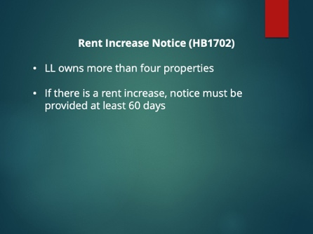 | Instructor:  For landlords who own 5 or more properties (or more than a 10% interest in 5 or more units) – the bill language is more than four - in Virginia, they will now be required to provide written notice to any tenant who has the option to renew a lease or whose lease contains an automatic renewal provision of any increase in rent during the subsequent rental agreement term. This notice must be provided no less than 60 days before the end of the rental term.  If you are using the Virginia REALTORS lease (Form 200), paragraph 1.j. allows for you to fill in any number of days for notice to terminate/renew. That is still fine, so long as the rent will not be increasing. Let’s say you’ve written 30 days in that field, but the owner wants to increase rent. You must give notice 60 days before the renewal, even though the lease only says 30 days notice.
Slide 13 | 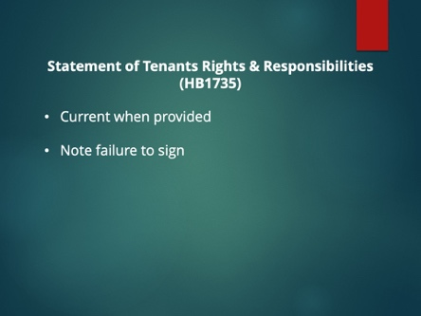 | Instructor:  The law says that if the tenant fails to sign the form, the landlord shall record the date on which they provided the form to the tenant and the fact that the tenant failed to sign the form.  It also states that subsequent to the effective date of the tenancy, a landlord may, but is not required to, provide the tenant with and allow the tenant the opportunity to sign the form – so essentially, at renewal, you are not obligated to provide the form again.  Finally, the law clarifies that the form must be current as of the date of delivery – not current when the unlawful detainer action begins.
Slide 14

