Slide 1 | 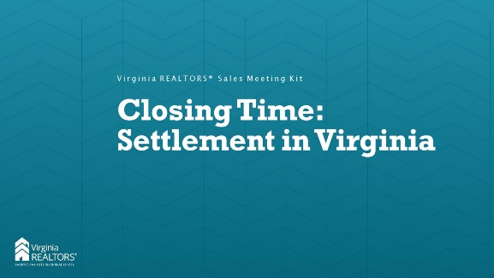
Slide 2 | 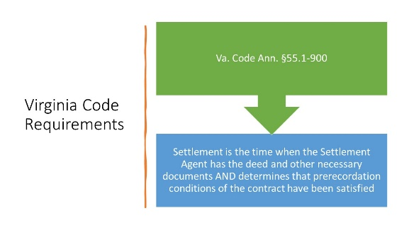 | Instructor: The code defines settlement as the time when the settlement agent has received the duly executed deed, loan funds, loan documents, and other documents and funds required to carry out the terms of the contract between the parties and the settlement agent reasonably determines that prerecordation conditions of such contracts have been satisfied. A determination by a settlement agent that prerecordation conditions have been satisfied shall not control the rights and obligations of the parties under the contract, including whether settlement has occurred under the terms and conditions of the contract. "Parties," as used in this definition, means the seller, purchaser, borrower, lender, and settlement agent.  Basically this happens when the SA has gotten the deed, docs from the lender, title search, and anything else needed (POAs, lien payoffs, buyer funds). Recordation is NOT required for “settlement” under the code.
Slide 3 |  | INSTRUCTOR: In Virginia, there is only one settlement agent for a transaction, and that agent is selected by the buyer. The code lists 16 things that are considered “escrow, closing, or settlement services” that must be done by the SA (or their designee). Basically this is everything but preparing the deed and paying recordation taxes. A licensed attorney can be a settlement agent, or a lay settlement agent (non-attorney) can handle the closing. An attorney would still have to draft the deed and any POA or affidavit required. Some companies have both lay settlement agents and attorneys, while others are separate. The seller can choose to have an attorney represent them, but they cannot engage a lay settlement company to work with them.
Slide 4 | 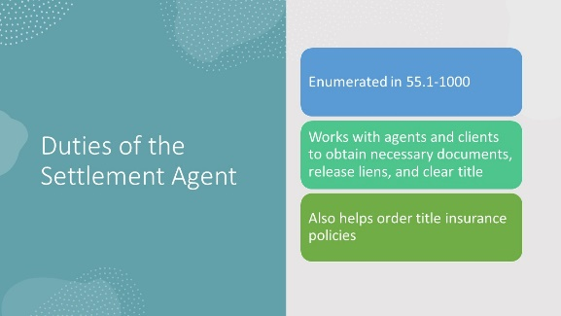 | INSTRUCTOR: The SA will run a title abstract to see if there is clear title to the property. They’ll order any payoffs that are necessary to satisfy mortgages or other liens on the property, and they will work to cure any defects in title (bad name on the previous deed, incorrect address, etc.). They will work with the lender (if there is one) to determine what docs are needed and determine the total amount of money that is being borrowed and that is needed at closing. They’ll also confirm whether the seller is a non-foreign person for purposes of tax law and ensure that the buyer has acceptable ID to conform to the Patriot Act requirement of lenders.
Slide 5 |  | INSTRUCTOR: You are your client’s first line of defense for questions regarding closing, as they may never have experienced it before. Make sure you work with the settlement agent and/or seller attorney and the lender to ensure that the client knows what they need to bring to closing (government-issued IDs, cashier’s checks if they are paying money at the table, keys if the seller is providing them at closing, etc.) or what they need to provide prior to closing. The more responsive your client is to the requests of the settlement agent, the smoother the closing will go. If things pop up like issues with title or with the loan process, you should be the go-between to assist your client. Finally, make sure the settlement company has your correct compensation information (including any admin fees), and review the draft closing disclosure or settlement statement to make sure that everything looks right before you get to the table.
Slide 6 |  | Instructor: The Settlement Agent will check title and determine if there are any outstanding liens on the property that need to be paid off and released before the transaction can close. The SA will also communicate with the seller’s attorney (if there is one) to ensure that the deed is correct and that all necessary documents are prepared. Typically the timeline for closing a conventional loan is 30-45 days, but cash deals can sometimes close within a week (basically as soon as title insurance is issued). It’s important to manage expectations for your client up front.
Slide 7 |  | Instructor: On the day of closing, the buyers will come in to the SA’s office and sign the documents. Lenders require that their docs be signed on the date of settlement, so you typically can’t come in early as a buyer. Sellers can sign early as long as the deed is prepared, though typically not more than a week before settlement. If the buyers are out of town or otherwise unavailable, the SA can arrange for the docs to be sent to the buyer and signed in front of a notary, then mailed back. After the notary confirms the IDs of the buyers, the buyers will sign the required documents and (usually) get the keys.
Slide 8 | 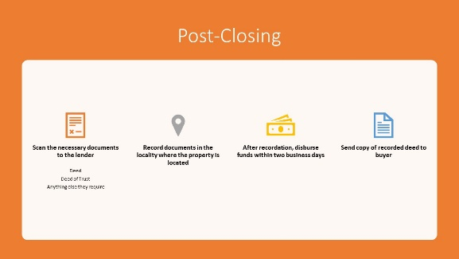 | Instructor: After the buyer has signed, the Settlement Agent will take the seller-signed deed and the buyer’s deed of trust, along with any affidavits, POAs, or certificates of satisfaction, and record them in the appropriate jurisdiction. Most places in Virginia allow e-recording, but some still require you to come in to the courthouse to record. 55.1-903 requires disbursement of funds within two business days of settlement, but not before recordation. If the contract states that keys will not be given until recordation, make sure your clients are aware of that ahead of time to prevent any unpleasant surprises at the closing table.
Slide 9 | 