Slide 1 | 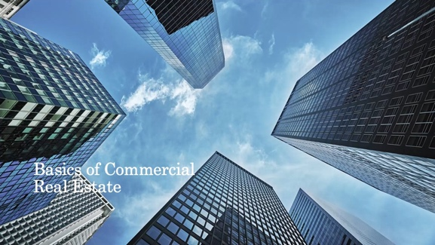 | This presentation is for agents that are new to commercial real estate and/or agents who are considering getting into commercial real estate. This presentation provides a general, high-level overview. If you are new to commercial real estate and begin engaging with commercial customers/clients, this presentation is not enough; you will need to familiarize yourself with additional details about commercial real estate.
Slide 2 | 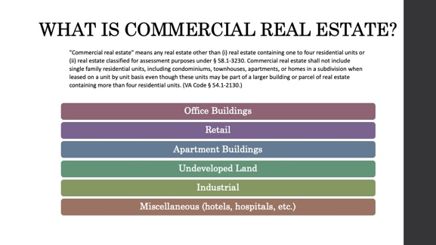 | As a real estate licensee, you are able to represent clients for both residential and commercial real estate.  Virginia Law defines commercial real estate as all real estate other than residential units or real estate classified for certain assessment purposes, which are (1) real estate devoted to agricultural use, (2) real estate devoted to horticultural use, (3) real estate devoted to forest use, and (4) real estate devoted to open-space use.  Some common examples of commercial real estate include: office buildings, retail shops, restaurants, apartment buildings (if the entire building is transacted and not unit by unit), undeveloped land, industrial use buildings, and other miscellaneous buildings such as hotels and hospitals.
Slide 3 | 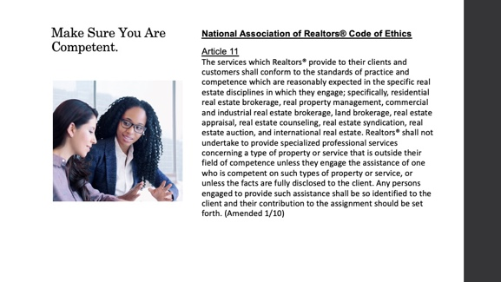 | First step before you begin working with commercial properties is to make sure you are competent.  Article 11 of the Code of Ethics requires Realtors to be competent in the specific real estate disciplines in which they engage. The best advice is to work with someone who is already competent in commercial real estate to help you learn the ropes.
Slide 4 | 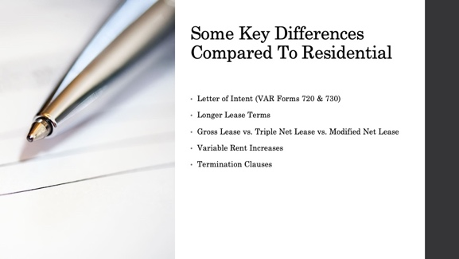 | Here is just a small taste of the key differences between Commercial and Residential Transactions.  Unlike residential transactions, commercial transactions usually do not begin by sending a lease contract offer or purchase contract offer. Instead, the prospective tenant or buyer sends a Letter of Intent (VAR Form 720 for purchase and VAR Form 730 for leases). The purpose of the Letter of Intent is for the parties to come to an agreement about the broad-strokes of a deal before the parties then solidify the details in a lease or purchase agreement.  Most commercial transactions are long leases. Whereas residential leases usually run for a year or so, commercial leases can run for much longer terms.  Additionally, in residential leases, the tenant usually only pays rent and utilities. However, commercial leases often involve what is called a “Triple Net Lease,” meaning the tenant pays not only rent and utilities, but also maintenance, insurance, and taxes. Sometimes a “Gross Lease” is used where the tenant does not pay these expenses. Other times, a “Modified Net Lease” will be used, where the tenant pays some of these extra expenses but not all three.  In a variable lease, the rent amount may change based on an index such as CPI, the rent may increase a certain percentage each year, or the rent may increase based on the usage or performance of the commercial enterprise leasing the property.  Commercial leases tend to be more complex than residential leases, and they often have early Termination Clauses. Make sure you read and understand these clauses so you can best serve your clients.

