Slide 1 |  | Instructor: Introduction
Slide 2 | 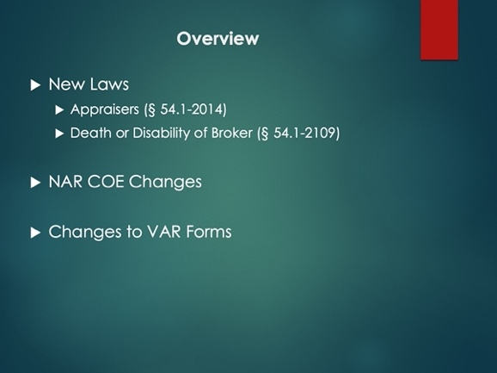 | Instructor:  Read slide
Slide 3 | 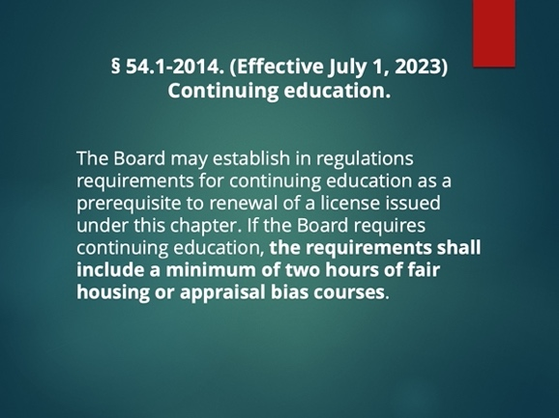 | Instructor: New law adds a minimum of two hours of Fair Housing or Appraisal Bias Courses for Appraisers.
Slide 4 | 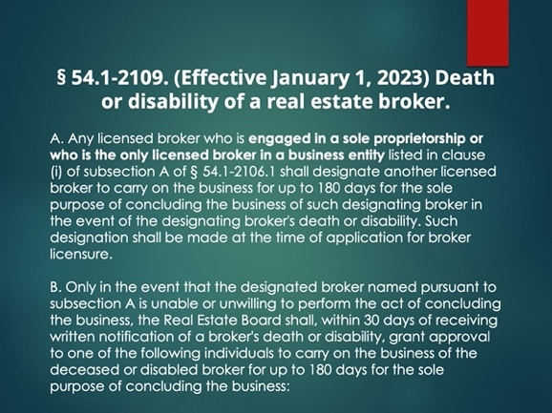 | Instructor: There is a very important change to the law coming on January 1st 2023 that hopefully will not impact you.  The current law as of the time of this recording has a list of 5 categories that DPOR must go through in order, in the tragic event of the death or disability of a real estate broker. The first change to the law is the addition of paragraphs A and modification of B. If you are a sole proprietorship or the only licensed broker in a firm, you must designate another Broker to conclude your business if you are unable to by death or disability.  DPOR has already been sending out letters to Brokers to designate another licensed Broker to wind down the business. Per the letter and the statute, this is ONLY necessary if you are a sole proprietorship or the only licensed broker in a FIRM. The letter which has been sent out requires you to return this to DPOR by December 31st, 2022. In the future, on January 1st 2023 this form will be available on DPORs website. So, if you are watching this later and need the form it will be available there.  If for some reason the Broker you designated is unable or unwilling to perform will then grant approval to one of the individuals in the 5 list category.
Slide 5 | 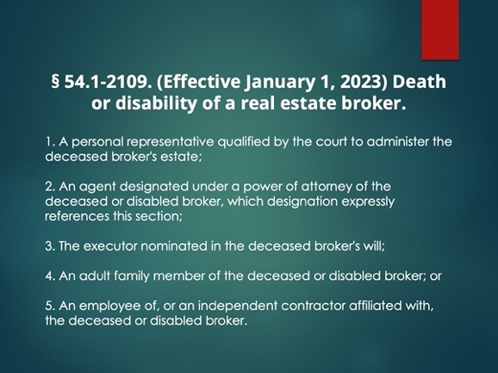 | Instructor: The list should look familiar because it is the same list as before. But please note from the previous slide that DPOR does NOT have to go in order. Therefore, they can grant approval to any individual in the 5 categories in any order. As you can see, category number 5 is very likely to be the most desirable one for the conclusion of the business.
Slide 6 | 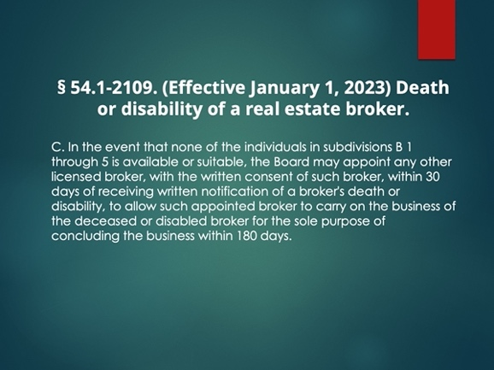 | Instructor: Last but not least. This may seem familiar to the old statute but there are some significant changes. DPOR will appoint another licensed Broker with their consent if they cannot find anyone suitable or available in the categorical list. The statute is now explicit that it will be another licensed Broker, not just a suitable individual
Slide 7 | 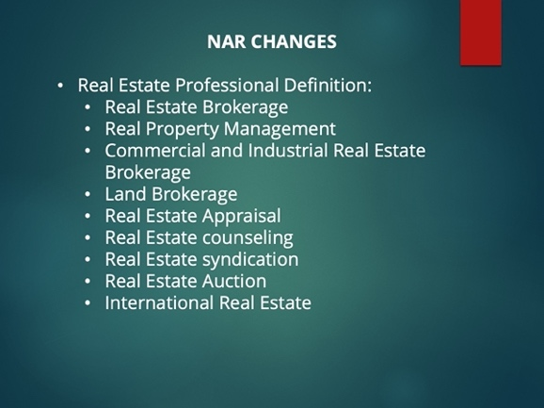 | Instructor: Definition of “real estate professional.” Section 1 of the manual has been amended to define “Real Estate Professional” as an individual engaged in the disciplines of real estate specified under Article 11 of the Code of Ethics. Those disciplines include residential real estate brokerage, real property management, commercial and industrial real estate brokerage, land brokerage, real estate appraisal, real estate counseling, real estate syndication, real estate auction, and international real estate.
Slide 8 | 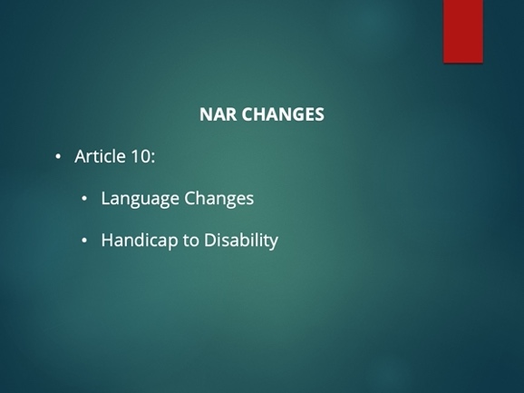 | Instructor: Article 10 is changing the word handicap to disability for inclusivity.
Slide 9 | 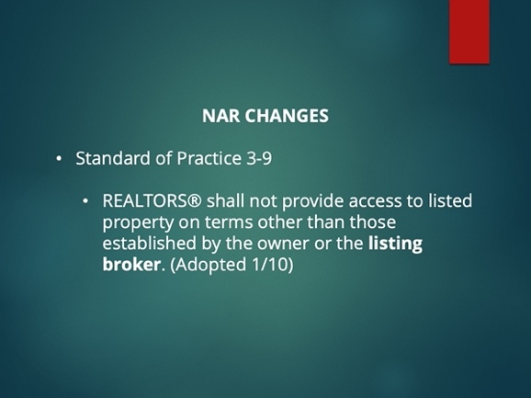 | Instructor: SOP 3-9 is also changing to "Realtors shall not provide access to listed property on terms other than those established by the owner or seller.”
Slide 10 | 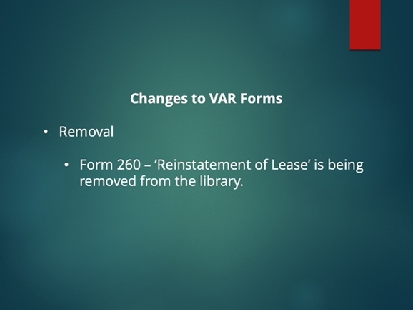 | Instructor: This form was used to reinstate a lease which had been nulled by a court order in more than likely an Unlawful Detainer. However, we found that the Form was not really being used and best practice is just to sign a new lease if you want to keep the tenant.
Slide 11 | 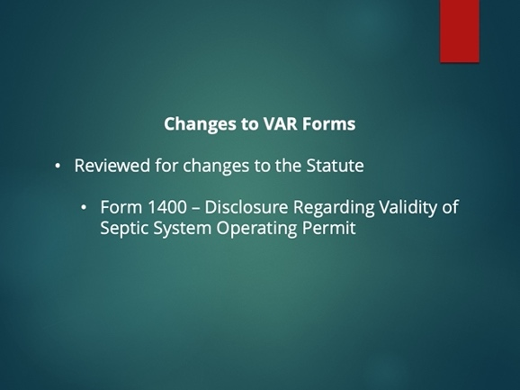 | Instructor: There were no changes to the statute, so you can be sure that this is still the latest and greatest.
Slide 12 | 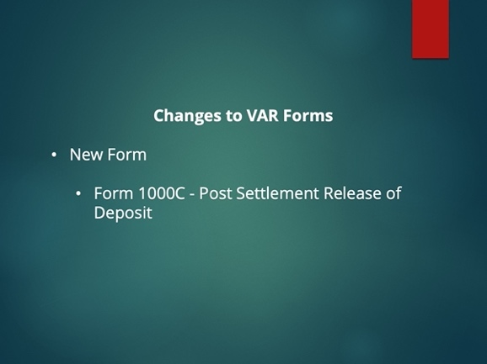 | Instructor: If a Seller is to remain in the Property after the sale and there is a deposit, this form should be used for the disposition of the deposit and its release.
Slide 13 | 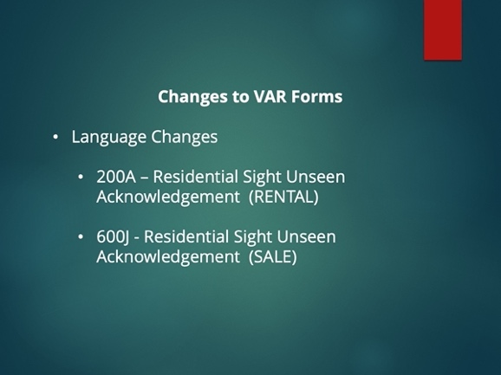 | Instructor: Modified language for inclusivity.
Slide 14 | 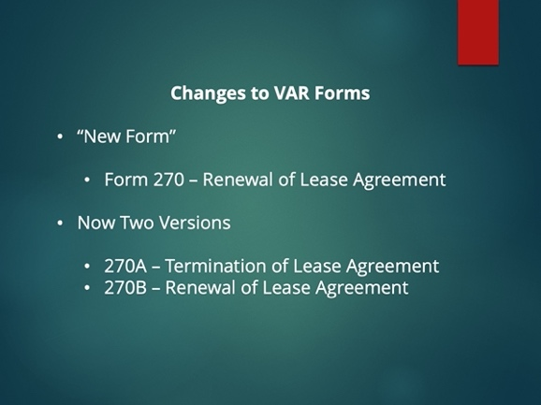 | Instructor: Form 270 still remains; however, now you have the option of sending one of the two and not just both at the same time if you so wish.
Slide 15 | 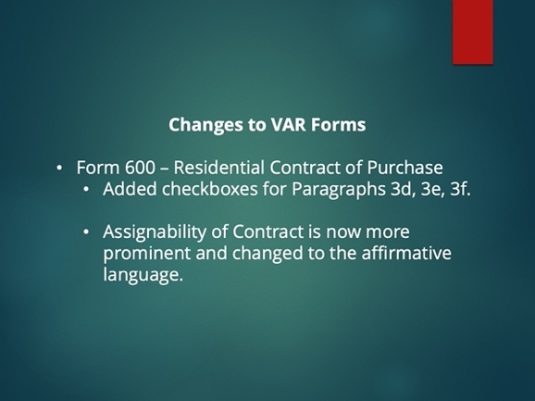 | Instructor:  Added check boxes for:  3d – balance of purchase price  3e – Seller concessions  3f – Other financing Terms  Also changed the assignability language to the affirmative:  Purchaser may assign this Contract in whole or in part, only with the prior written consent of Seller, which Seller shall be under no obligation whatsoever to give.
Slide 16 | 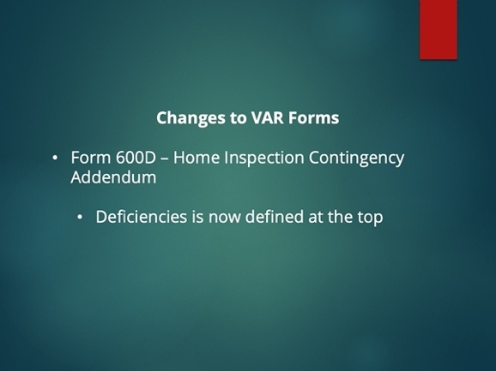 | Instructor: The term deficiencies is now defined at the top. Before it was in the middle of the contract; however, now it is clear at the top. 600D only allows for deficiencies to be used as part of the negotiation.
Slide 17 | 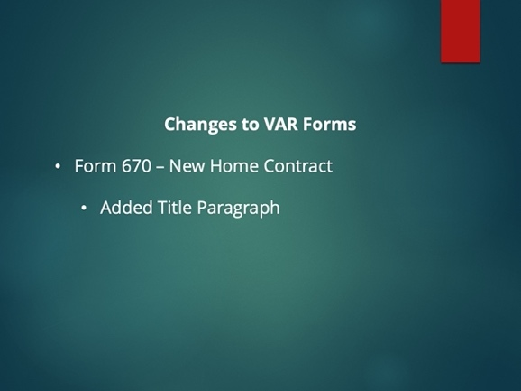 | Instructor: Form 670 now includes a paragraph where Title must pass with covenants.
Slide 18 | 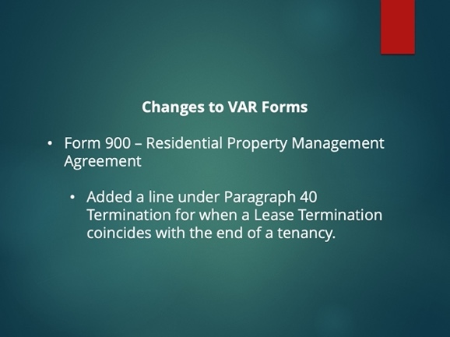 | Instructor: Paragraph 40 - Termination – Added: If this Agreement is terminated coinciding with the end of a tenancy, Agent will comply with requirements of this Agreement related to the end of a tenancy, to include move out inspection and security deposit disposition.  If this is not to be the case, please make sure that you state this in the termination/release of PMA – 900A.
Slide 19 | 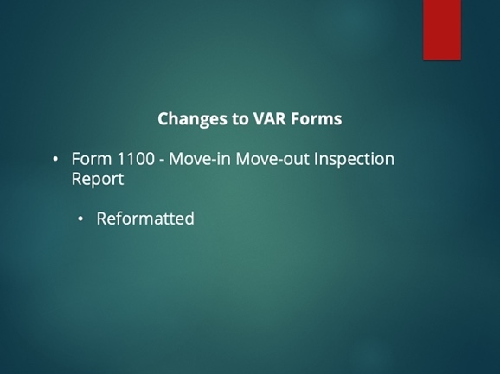 | Instructor: Reformatted for clarity and added more lines for Other.
Slide 20 | 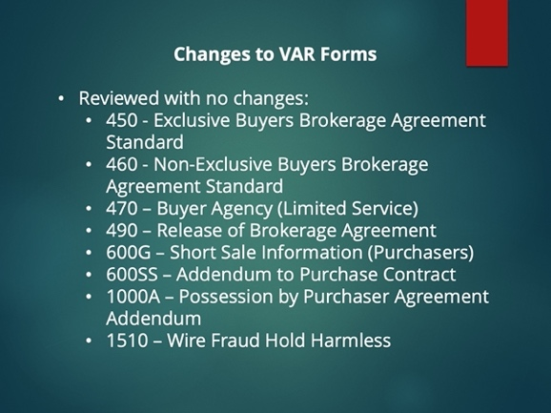 | Instructor: These forms have been reviewed and no changes have been made.
Slide 21

