Slide 1 |  | Information in this presentation is a summary of the advertising requirements under the Virginia Real Estate Board Regulations and the National Association of REALTORS Code of Ethics.  If your individual firm has additional requirements beyond those spelled out in this presentation, you should include those.  Reference:  18 VAC §135-20-190. Advertising by licensees. (https://law.lis.virginia.gov/admincode/title18/agency135/chapter20/section190/)  NAR Code of Ethics, Article 12
Slide 2 | 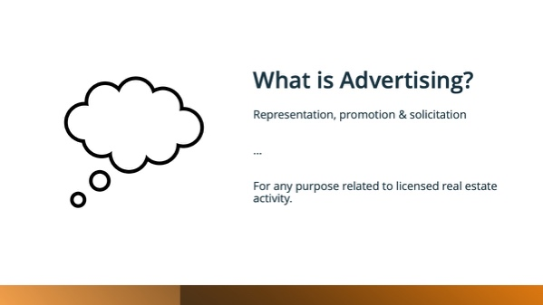 | "Advertising" means all forms of representation, promotion and solicitation disseminated in any manner and by any means of communication to consumers for any purpose related to licensed real estate activity. This is a very broad definition and covers both obvious and non-obvious things. Ask yourself, could what I’m doing be reasonably seen as an attempt to gain business? If so, then it’s likely advertising.
Slide 3 | 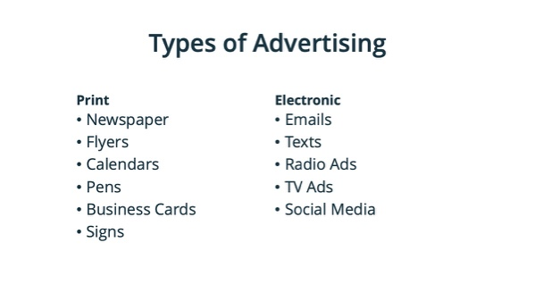 | Virginia regulations break advertising into two type: Print and electronic.  Print advertising is anything tangible – newspapers, flyers, calendars, pens, etc. as well as business cards & signs.  Electronic advertising, on the other hand, is just about anything else – emails, texts, radio ads, TV ads, social media, etc.
Slide 4 | 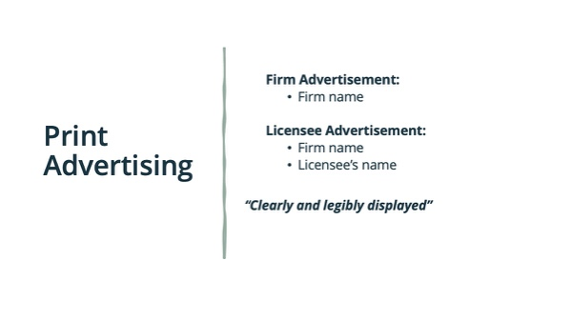 | Within Print Advertising, there are three categories: Business cards, for sale/lease signs on the property, and everything else.  For everything else, firm advertisements must have at least the firm name. For licensee advertisements, you must include at lease the firm name and your name.  You can include additional information if you want, but these are the minimum requirements.  Remember, the required information must be “clearly and legibly displayed.”
Slide 5 |  | Business cards, while a type of print advertising, have different required disclosures. Business cards must contain at least the licensee’s name, firm name & contact information. “Contact information” means the agent’s telephone number or web address.  Your business cards can include additional information, but it must have at least these three things.
Slide 6 | 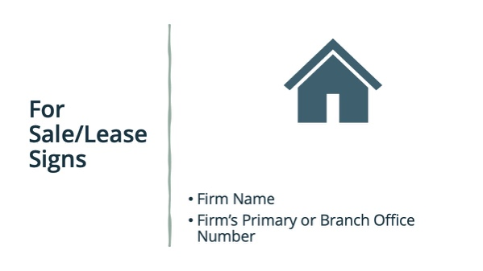 | Any for sale or for lease signs placed ON the property must contain at least the firm’s name and the firm’s primary or branch office number. Again, like with business cards, you can include additional information, but this is the minimum.
Slide 7 |  | Remember, electronic advertising is anything that is not print advertising.  For electronic advertising, firms must include the firm’s licensed name and the city and state of the firm’s main or branch office. Agents must include essentially the same information - the agent’s name, the firm’s name, and then the city and state of the agent’s place of business.  The Code of Ethics requires REALTORS to also include the states the agent is licensed in.  There is no need to include your license number in Virginia, but you can if you want to.
Slide 8 | 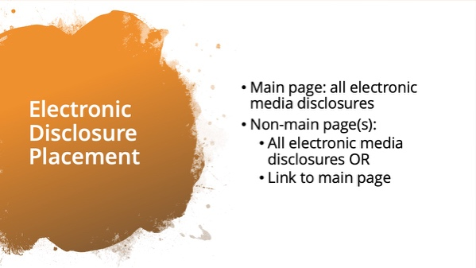 | All electronic media disclosures must be clearly and legibly displayed.  The agent’s main (home) page, must include all of the required disclosures, but there is no requirement on where they are placed. They can be located in a footer at the bottom of the page.  Any non-main page must either include the required disclosures or a link back to the main page which does have the disclosures.  For a non-agent or firm owned website, like Facebook, you must include at least a link back to your main page, which has all of the required disclosures.  Many people know this as the “one-click” rule because the disclosures must be no more than one click away from the advertisement.
Slide 9 |  | Agents must include in all advertising that the owner is a real estate licensee if the licensee owns or has any ownership interest in the property advertised.  This is new as of 2015, when the new regulations required the disclosure even if the property was listed with a firm and not a “FSBO.”  This requirement includes for sale or for lease signs placed on the property, and can be met with an “Agent / Owner” sign rider.
Slide 10 | 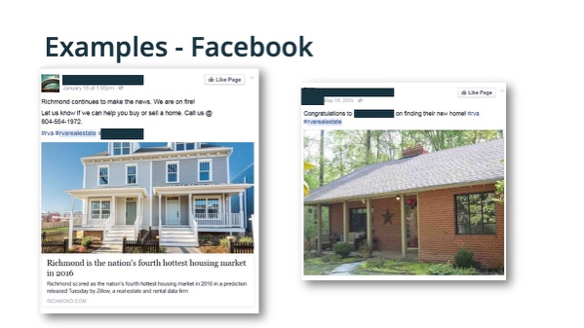 | Here we have some real postings from Facebook. First are these even advertisements? [ask for audience input].  They are. The intent by putting them out there is to try to get business, whether by offering an item of value or putting yourself out there as an expert.  Remember, Facebook is a non-realtor owned site. So the realtor only needs to provide a link back to his/her main webpage where the proper disclosures are located.  Are these compliant? [ask for audience input].  No, they are not. There is no link back to the REALTOR main webpage and there are no disclosures on the post.
Slide 11 | 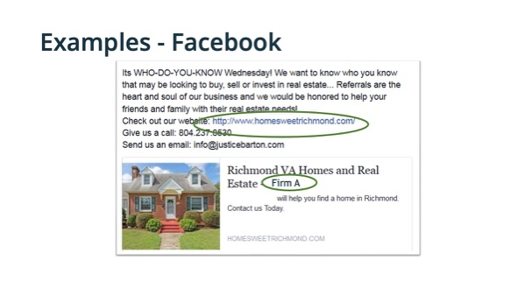 | Here is another Facebook posting that is in compliance with the regulations. We have the firm name clearly and legibly displayed [click] and a link back to the REALTOR-owned website’s main page [click], assuming the website is compliant.
Slide 12 | 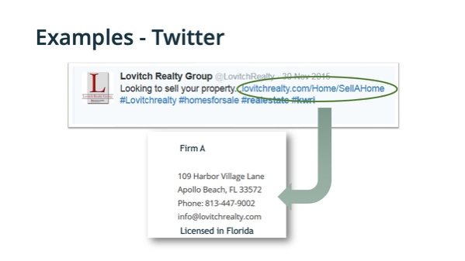 | Here is an example from twitter. This tweet is in compliance because it includes a link back to the REALTOR-owned main webpage [click] and if we follow the link, we find all the required information disclosed [click].
Slide 13
Slide 14 | 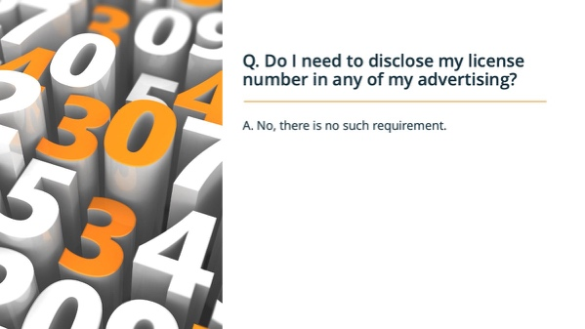 | First question: Do agents need to disclose their license number in their advertising? [ask for answers]  [click for answer]  No, agents do not need to include their Virginia License number. They must disclose their states of licensure if they are advertising online.
Slide 15 | 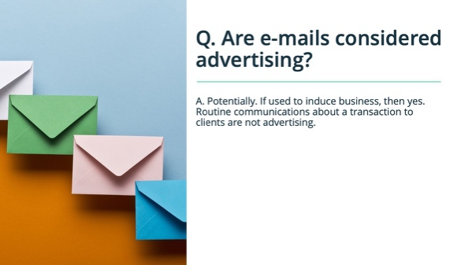 | Second question: are emails considered advertising? [ask for answers]  [click for answer]  The answer is “potentially.” If the emails are being used to induce business, then they are considered advertising. Routine email communications between you and an existing client about a transaction are not advertising. However, if there is any chance that an email account could be used for advertising; the required disclosures should be included in a signature file or in the email itself.
Slide 16 | 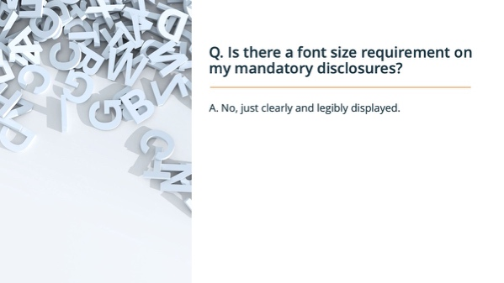 | Third question: are there font size requirements for mandatory disclosures? ? [ask for answers]  [click for answer]  The regulations do not have minimum font or size requirements, so long as the disclosures are clearly and legibly displayed.  NOTE: If the firm has additional requirements, mention them here.
Slide 17

