Slide 1
Slide 2 | 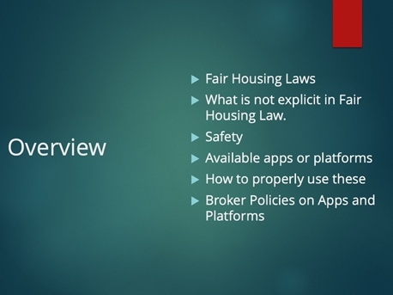 | Instructor: Today we’re going to talk about several things. We’re going to go through a brief overview of Fair Housing Laws, What’s not included in the Law but you should be aware of, Safety, What kind of apps or platforms are available, how to use these while staying safe but also on the right side of Fair Housing, what a Broker should include in office policies regarding the apps. We’re also going to talk about record retention and how you can avoid an unfortunate situation from turning into a complete catastrophe. Lastly, we’ll cover the new business continuity law which will be effective on January 1st, 2023.  Just as a reminder Virginia REALTORS® has a number of resources – recordings of Facebook Lives, podcasts, and a other resources which also touch on these subjects.
Slide 3 | 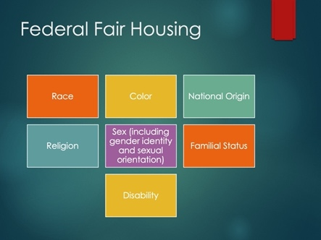 | Instructor: We’re going to start by talking about the Federal Fair Housing Act. 42 U.S. Code § 3604.  The protected characteristics are on the slide.
Slide 4 | 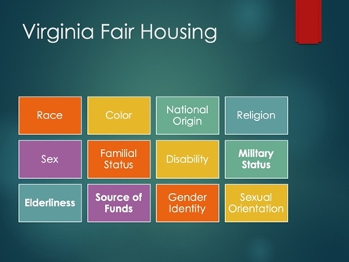 | Instructor: Virginia has its own version of the Fair Housing Act. Virginia Fair Housing Law § 36-96.1. Virginias Fair Housing Law adds some protected characteristics. They are the ones listed here in bold. Military Status, Elderliness, Source of Funds.
Slide 5 | 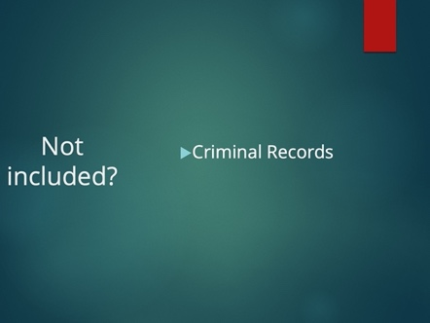 | Instructor: Criminal records, such as arrests and or convictions, are not a protected characteristics under either the Federal or Virginia Acts. So why does it matter? In short, the Department of Urban Housing and Development, HUD, released a guidance document in 2016 which provides how the use of criminal records can run afoul of Fair Housing.
Slide 6 | 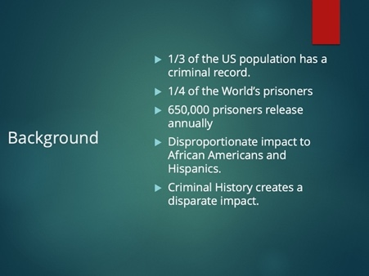 | Instructor: The decision for HUD to add criminal history to its enforcement of Fair Housing has a lot to do with the background surrounding it.  As of 2016, 100 million US adults, almost one third of the population, have a criminal record.  In 2012, despite being 5% of the world population, the US held almost ¼ of the world’s prisoners.  Since 2004, an average of 650,000 individuals have been released annually from federal and state prisons and over 95% of them will be released at some point in time.  African Americans and Hispanics are arrested, convicted, and incarcerated at a rate which is disproportionate to their representation in the US population.  People with a criminal history face many challenges in finding and securing housing after an arrest or their release from incarceration. Compounded with the statistics a disparate impact is now created on protected characteristics.
Slide 7 | 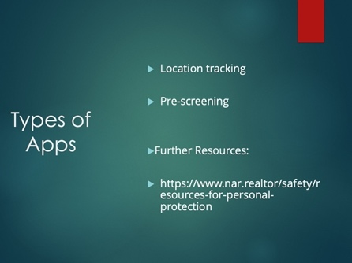 | Instructor: At its most fundamental level there are two kinds of apps that we’ll be discussing.  The first is location tracking. This type of app is very simple, it tracks your location. Some of these kind of apps are just that simple, it tracks and shares your location with someone. Some of them have a timer so when you go show a property you start a custom timer and at the end if you don’t check in, some will contact a person you selected and / or will notify the authorities. Others have you take a picture with the client before the showing, while others have you take a picture of their license. Some will create a phone call so that you can step away and notify authorities if you feel unsafe.  Even so, the basic application is the same, it tracks your locations, but some have more features than others!  The second is a pre-screening app. These kind of apps are likely to be used more on prospective client. You take whatever information you have on the client, name or phone number for example and plug it into the app. These apps can give you things such as the current ownership of home. It may provide you with bankruptcies or liens. Some of these apps also identify if your prospective client has a criminal history.  Just as a note, these apps does not provide you a credit history or credit score, so they are not determining any sort of credit worthiness. Credit history is covered under the Fair Credit Reporting Act and because these apps do not provide any sort of credit worthiness valuation they are not covered by the Act.  The National Association of REALTORS® provides a comprehensive list on the link I provided here. Just like NAR, Virginia REALTORS® does not endorse, nor has vetted any of these products or apps. The link provided is merely for informational purposes and no inference should be drawn that we have a preference on anything listed.
Slide 8 | 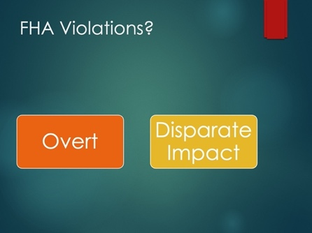 | Instructor:  The two clear ways to violate Fair Housing by using apps or having a policy on apps is through overt discrimination or by taking actions or having policies that have a disparate impact on a protected class. Overt discrimination would consist of taking actions or having policies which explicitly target a protected class. Disparate impact, would consist of either taking actions because of someone’s protected class even though it gives the appearance of being neutral. Disparate impact applies as well to policies where they appear to be content neutral; however, its impact is felt by protected classes more so than non-protected classes.
Slide 9 | 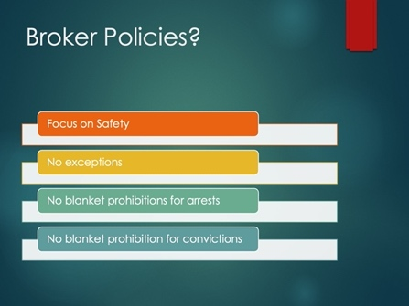 | Instructor:  Your policies should be crafted with safety as the main interest. There should be no exceptions to the policy, using uneven exceptions is how you can run afoul of Fair Housing. No blanket prohibitions for arrests or convictions should be in your policy. It should include guidelines which indicate how to preserve your interest in safety.  The intent of your policies should be to maintain the safety and wellbeing of your agents and yourself. Policies or actions cannot be disguised as a pretense to discriminate against someone because of a protect class. The main takeaway from this should be that if you are using these apps you need to use them in a manner which would not be questioned if you receive a Fair Housing complaint. Other than overt
Slide 10

