Slide 1
Slide 2 | 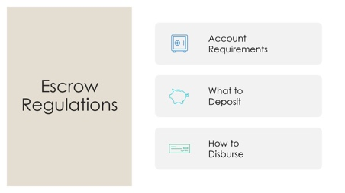 | Instructor: Today we are going to go over the essential escrow regulations you need to know to stay out of trouble. Escrow violations are some of the most common VREB violations because escrow deals with other people’s money, and facts are relatively easy to determine. We’ll discuss escrow account requirements, what needs to be deposited into an escrow account, and how to disburse funds when necessary. We’ll also go over the five escrow violations listed in the regulations.
Slide 3 | 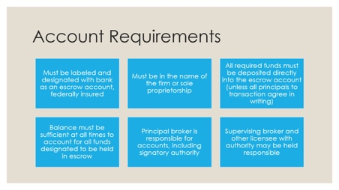 | Instructor: There are a number of requirements for escrow accounts. [Read requirements] For agents, the most crucial requirement is that all required funds must be deposited directly into the escrow account, unless all principals agree in writing. The deadline VREB gives for “direct” is within five business banking days. Note also that the escrow account must be in name of the firm – it cannot be, for example, in the name of a team.
Slide 4 | 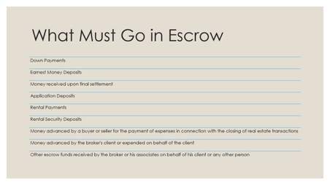 | Instructor: Here is a list of funds that must go into an escrow account, not an operating account. This includes all rent payments.
Slide 5 | 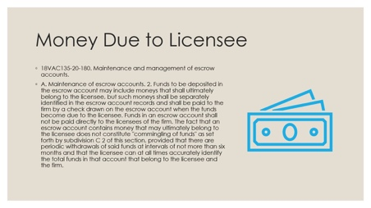 | Instructor: There may also be money ultimately due to a licensee that goes into the escrow account. However, that should be separately identified in the escrow account records and must go to the firm before going to the licensee.
Slide 6 | 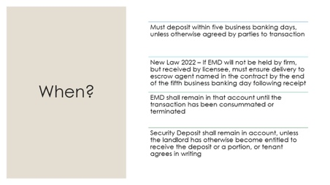 | Instructor: We already mentioned that funds must be deposited into the escrow account within five business banking days, unless the parties to the transaction agree otherwise in writing. If you are using the Virginia REALTORS purchase contract, it states that the parties direct the Escrow Agent to place the Deposit in an escrow account by the end of the fifth business banking day following the latter of: (i) the date [the] contract is fully executed by the parties, or (ii) receipt during the Extended Deposit period. Above that language is a place for the purchaser to note if they have paid the deposit already (in which case you would have it to put into the escrow account) or WILL PAY the deposit within a certain # of days of ratification (defined as the Extended Deposit Date).  There is a new law passed in 2022 that states if a licensee receives an EMD but they do not hold escrow or will not hold this EMD, they must ensure delivery to the escrow agent named in the contract by the end of the fifth business banking day following its receipt.  EMDs must remain in the account until the transaction closes or is terminated/released. Security deposits must remain in the account until the landlord becomes entitled to receive it, or part of it, or if the tenant agrees in writing.
Slide 7 | 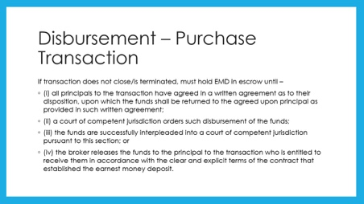 | Instructor: When your transaction does not close, you must hold the EMD in the escrow account until one of these four things happens. First, all parties to the transaction could agree in writing how the EMD will be disbursed – this is usually done through a Release. Second, a court could order disbursement of the funds; for example, if one party sues the other for the funds. Third, the broker can interplead the funds to the court. We’ll talk about this more in a minute. Fourth, the broker could release the funds to a party entitled to receive them if the contract is clear and explicit that the party should receive them. This can be used for things like a buyer who terminates under the POA Act or a Home Inspection Contingency that allows a buyer to receive the funds back, but the other party will not agree to release them. A broker does not have to do this, but may.
Slide 8 | 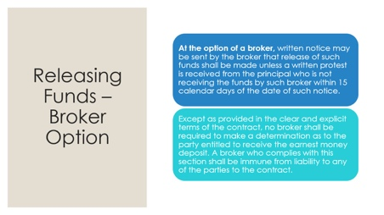 | Instructor: The regulations also note that, should the broker choose, they may send written notice that they will release the funds unless they receive a written protest from the other party within 15 calendar days of the notice. They do not have to send the notice, but may choose to if they feel the disbursement may be contentious.
Slide 9 | 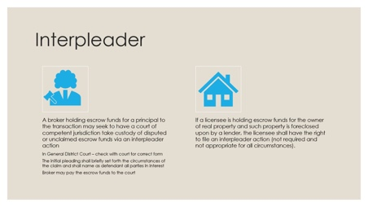 | Instructor: An interpleader is when a person holding funds for other parties (who dispute who is entitled to the funds) files a form with the General District Court stating the names and addresses of the parties involved, the amount in controversy, and why it’s in controversy – for example, because the parties signed a real estate purchase contract which did not close, and the parties dispute who is entitled to the funds. The court should then take possession of the funds, and the brokerage can generally remove themselves from the process. The judge will decide who is entitled to the funds and the court will distribute them. You can also interplead funds in some foreclosure circumstances.
Slide 10 | 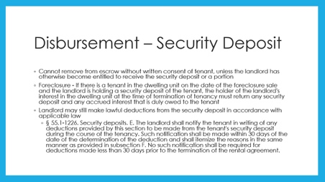 | Instructor: Security deposits must remain in the escrow account unless the landlord becomes entitled to them or the tenant agrees otherwise in writing. The landlord/property manager may still make lawful deductions in accordance with applicable law – this is an example of the landlord becoming entitled to the funds. They must notify the tenant in writing, within 30 days of determining the deduction, and shall itemize the deduction. If there is a tenant in a property that is being foreclosed on, the foreclosure will serve as a termination of the lease and the landlord/property manager must return any security deposit to the tenant.
Slide 11 | 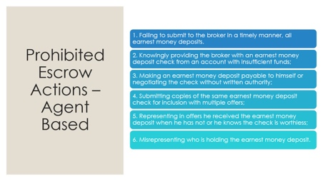 | Instructor: As we noted at the start, escrow violations are one of the most common licensee violations found. VREB regulations lay out six prohibited acts for licensees dealing with earnest money deposits. First, it’s a prohibited act for a licensee to fail to submit an EMD to the broker in a timely manner (five days or otherwise agreed to by parties). Second, knowingly providing the broker with a check from an account with insufficient funds – so, if your client says to you, “here’s my EMD check please don’t cash it for 8 days because that’s when I’ll get paid,” you would then know that when you give the check to your broker for deposit within five business days, the account would likely have insufficient funds. The third violation is self-explanatory. The fourth brings up some questions – submitting copies of the same EMD for inclusion with multiple offers. Does this mean that your buyer client who doesn’t get a property can’t use the same EMD for the next property? This is likely fine but up to broker policy regarding risk. This regulation is more likely geared towards submitting one EMD for use with multiple offers at the same time – it’s impossible to have that one EMD cover two properties if both offers get accepted simultaneously. The fifth violation is representing you’ve received the EMD if you haven’t and the second part is similar to #2 – if you know the EMD check is worthless, you cannot accept it as valid. Finally, you cannot mispresent who is holding the EMD. If you haven’t received it yet, the contract should not state that you have.
Slide 12 | 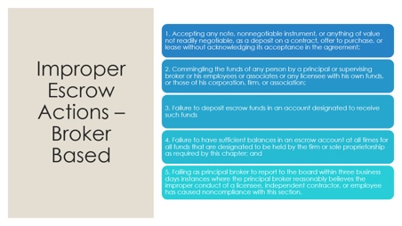 | Instructor: The VREB regulations also lay out five primary escrow violations which are generally broker-based. First, accepting any deposit on a contract or lease without acknowledging its acceptance in the agreement. Ensure the Earnest Money Deposit of your contracts is completed carefully and correctly! Second, commingling funds – mixing escrow funds with other funds. Remember – this doesn’t include money in the escrow account that will belong to a licensee at some point, so long as it is correctly identified. Third, failure to deposit escrow funds into escrow. Fourth, failing to have sufficient balance in the account to cover what’s designated to be held. So, if your client never gets you the earnest money deposit the contract says you will be holding, you may have an issue here. Work this out as soon as possible with your client by amending the contract or otherwise. The fifth improper escrow action is it’s a violation for a broker to not report to the Board within 3 business days of any instance where they believe the improper conduct of their agent or employee has caused noncompliance. That’s why it’s so important to discuss any escrow issues as quickly as possible!
Slide 13 | 