Slide 1 | 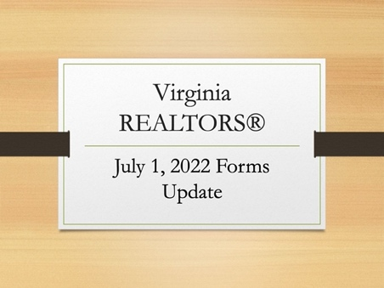
Slide 2 | 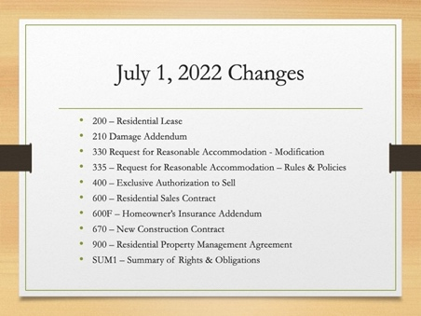 | Virginia REALTORS® has 10 forms that are changing. [read slide] we’ll talk about the changes to each of these forms, and redlines are available on the Virginia REALTORS® website.  Some of these changes are prompted by changes in the law, some are based on requests from the field, and others are based on the routine review of the Virginia REALTORS library. The Standard Forms Subcommittee reviews each form at least once every five years or so, in order to catch any changes that may need to be made based on changes in business practices or for risk management, even when there may not be changes prompted by changes in the law. If you ever have any suggested changes, you can send those to forms@virginiarealtors.org.  In addition to these, we have two that are being removed from the library:  - 600C – Disclosure of Multiple Offers  - 720 – Commercial Letter of Intent  They have heard that these two forms are not widely used, and are therefore being removed from the library.
Slide 3 | 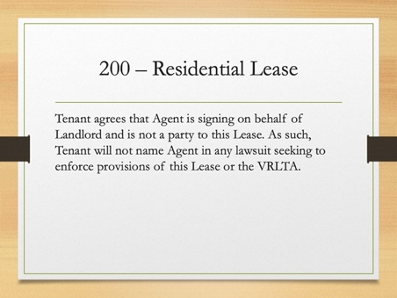 | For once there weren’t major changes to the Virginia Residential Landlord Tenant Act (VRLTA), which means that the changes to the lease are minor.  In fact, there’s only one change to the lease, which can be found on the last page.  The new language is on the screen. Virginia REALTORS® has been hearing that tenants will often add the property manager to any lawsuit under the lease, and while the property managers are often able to get the judge to dismiss them from the case, it takes time, energy, and money to do so. This new language is intended to reduce the number of times the property manager is named in a lawsuit, and when they are named, hopefully make it quicker and easier to get dismissed from the suit.
Slide 4 | 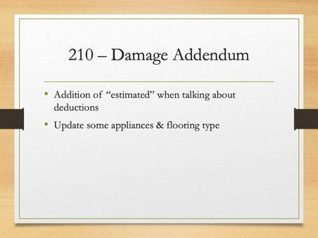 | This is a form that was updated as part of the routine review of the library.  There are two basic categories of changes.  The first is language added in paragraph one and new paragraph 2. With the massive shortages and price increases due to supply chain issues from the pandemic, damage addendum estimates from even two years ago could be wildly inaccurate. These changes make it clear that the amounts on the addendum are estimates based on current market conditions and that reasonable adjustments may be made for market conditions at the end of the lease.  The other is that some of the appliances have been updated and different types of flooring have been added as standard fields. These are based on feedback from property managers about what is now more typical in rental properties.  You will also notice that the signature fields have been updated to conform with the format that Virginia REALTORS is shifting towards with all our forms.
Slide 5 | 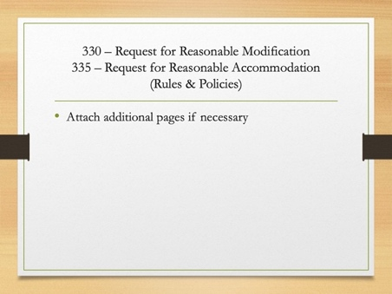 | Both of these have the same, minor change – the addition of language instructing the tenant to attach additional pages if necessary.  While this may seem minor, some tenants were trying to fit too much information in the limited space on the form & were not using additional pages.
Slide 6 | 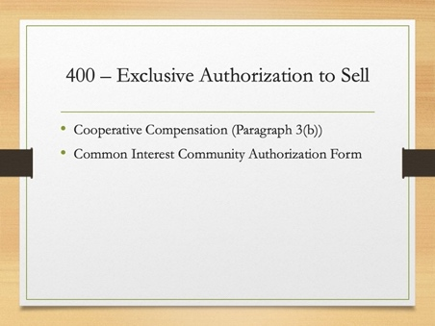 | There are two changes to the listing agreement.  Virginia REALTORS® has frequently heard about sellers misunderstanding how cooperative compensation works and that agents are having to explain that the cooperative compensation in paragraph 3(b) is part of the total fee paid by the seller. The sentence “Such compensation shall be paid by Owner at settlement.” has been deleted, while the cooperative compensation is an obligation of the seller that must be paid by the seller, that is because it is part of the total fee owed to the listing agent. This should reduce confusion.  The second change is on the final page of the file, which is the Common Interest Community Authorization Form. One of the changes in the law from the 2022 General Assembly session requires any authorization form for real estate agents to be recognized by a common interest community – an HOA or Condo – include the licensee’s real estate license number. A new field for this has been added to the form.
Slide 7 | 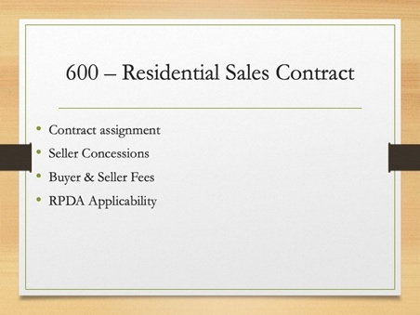 | There have been a number of changes made to the sales contract.  You’ll notice that throughout the form, where there are date fields, they have traditionally been “blank comma 20 blank” – that’s being changed so it’s one long field for the date. This will better conform with online platforms and how most agents fill in forms.  The first substantive change is language regarding the buyer’s ability to assign the contract has been moved from below paragraph 3(c) to the beginning of the contract. The old location lead to confusion on whether the purchaser was prohibited from assigning the contract at all, or only when seller financing was involved.  A new paragraph 3(e) has been added. This paragraph is for use with seller concessions or other closing costs that the seller will pay for the buyer. This is separate from the costs that are identified in the new paragraph 10(b) which are only for the costs that are charged to the seller that the seller is paying for.  The next two changes can be found in paragraph 10. Language from paragraph 10(a) regarding the seller paying deed prep and recordation tax has been moved into paragraph (b). This now has paragraph 10(a) addressing buyer fees and 10(b) addressing seller fees. In addition, the language in paragraph 10(b) that was added in April 2022 has been tweaked slightly. First, the word “additional” has been added to make it clear that the amount in the blank is what the seller will additionally be paying related to escrow, closing, or settlement services as defined in the law. Finally, the default amount of $250 has been dropped to zero. We started hearing that there were settlement agents who previously were not charging sellers, saw that as the “standard” or what they “should” charge sellers. We do not want to create a situation that increases fees for sellers.  In paragraph 26, a check box was added to indicate the Virginia Residential Property Disclosure Act does not apply. Virginia REALTORS® heard that sometimes there was confusion when the “is not attached” box was checked – is it not attached because it’s not applicable or because they haven’t bothered to attach?
Slide 8 | 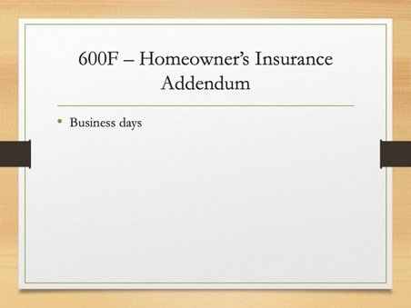 | Previously this form had both calendar and business days for deadlines. The form has been updated to be consistent and only use business days.
Slide 9 | 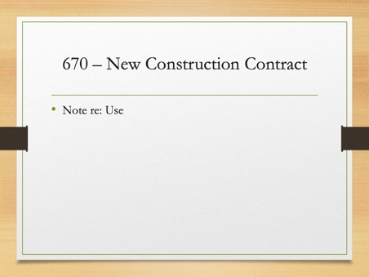 | The first change on the New Construction Contract is that a note has been added to the very top of the form. This form is intended to be used by a builder who is building a single home on a single plot of land – not for a developer who is subdividing a parcel and creating a new community. There are some builders who have been using this form, when working with a REALTOR, to develop new communities – for those situations, the builder should work with an attorney to draft an addendum to ensure that the provisions that are specific to new communities are addressed.  Language for the Condo & POA Acts have been added – the thought was that it’s possible for a builder to do a tear down and new construction in an existing community where HOA or Condo Acts would apply. To ensure that the contract is compliant in these situations, these paragraphs can now be used.
Slide 10 | 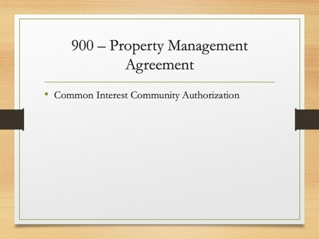 | The only change to the Property Management Agreement is the same change that was made in the listing agreement & is to the Common Interest Community Authorization form to add the Real Estate license number for the property manager.
Slide 11 | 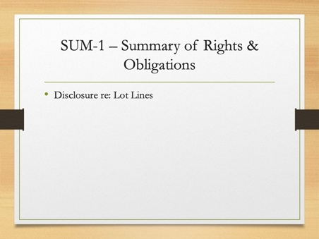 | The final form to change is the Summary of Rights & Obligations of Sellers & Purchasers Under the Virginia Residential Property Disclosure Act.  The RPDA was updated in the 2022 General Assembly Session to add a new “disclosure” about lot lines & the fact that the seller is not making any representations of warranties about lot lines.

