Slide 1 |  | Instructor: Today we’re going to talk about the bills from the 2022 session that are most likely to impact your day to day business or that you need to be aware of. Virginia REALTORS® has a number of resources – recordings of Facebook Lives, podcasts, and a comprehensive summary of even more legislation available on their website.  Before we begin, unless otherwise noted, all of these bills are effective on July 1, 2022.
Slide 2 |  | Instructor: We’re going to start by talking about a bill that is relevant to your business.
Slide 3 |  | This may seem minor, but it could be very helpful for those of you who have set up an LLC. The State Corporation Commission is now authorized to create a process that allows for the online payment of annual registration fees for two or three years.  This will make it easy to handle your registration for several years at a time.  https://lis.virginia.gov/cgi-bin/legp604.exe?221+ful+CHAP0290+hil
Slide 4 |  | Instructor: Let’s talk about two related bills related to Common Interest Communities – these are HOA and Condo developments.
Slide 5 |  | These are the first two bills of the Virginia REALTORS® Legislative Package that we’ve come to.  These two bills continue to tweak the laws that require condo and property owner associations to recognize real estate licensees that are representing an owner in the community. Now, the law states that the owner authorization must include the agent’s name, contact information, license number, and the owner’s signature.  You’ll see an update to the Virginia REALTORS® listing and property management agreements that contain the owner authorization form on July 1 with the new field for the agent’s license number.  https://lis.virginia.gov/cgi-bin/legp604.exe?221+ful+CHAP0065+hil
Slide 6 |  | Instructor: Let’s talk about the two updates to the Virginia Residential Property Disclosure Act.
Slide 7 | 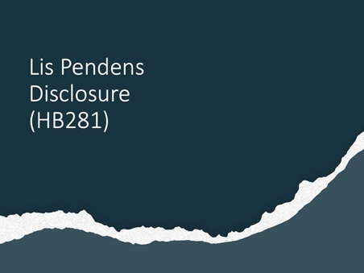 | The Residential Property Disclosure Act was updated to add a new affirmative disclosure – if the owner of a residential dwelling unit has actual knowledge of a lis pendens filed against the property, the owner must provide prospective buyers a written disclosure on a form provided by the VREB.  https://lis.virginia.gov/cgi-bin/legp604.exe?221+ful+HB281ER+hil
Slide 8 | 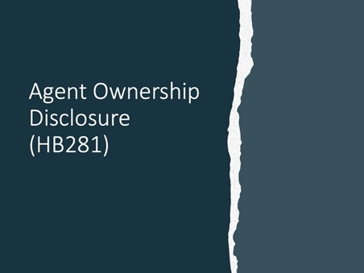 | The general assembly also took disclosure language from the VREB regulations and made it part of the law – nothing will actually change in your daily practice, but we wanted to mention this because it’s the second part of the bill we just discussed.  This requires licensees to disclose when they, any member of their family, their firm, or any entity in which they have an ownership interest is acquiring or attempting to acquire or is selling or leasing real property. This disclosure must be in writing & given to the other party upon having substantive discussions about specific real property.  https://lis.virginia.gov/cgi-bin/legp604.exe?221+ful+HB281ER+hil
Slide 9 |  | This bill adds language to the Residential Property Disclosure Act Statement – the list of “disclaimers” – that the owner is making no representations with regard to the current lot lines, or the ability to expand, improve, or add any structures on the property, and that purchasers are advised to do whatever due diligence they deem necessary, including obtaining a property survey and contacting the locality to determine zoning ordinances or lot coverage, height, or setback requirements.  https://lis.virginia.gov/cgi-bin/legp604.exe?221+ful+CHAP0268+hil
Slide 10 |  | Instructor: We know that not all of you have employees, but we did want to touch on one bill that updates both employment laws & fair housing.
Slide 11 |  | This bill defines “religion” for the purposes of discrimination in both employment and fair housing as “all aspects of religious observance, practice, or belief.”  https://lis.virginia.gov/cgi-bin/legp604.exe?221+ful+HB1063H1
Slide 12 |  | Instructor: We know that health insurance is an important issue to REALTORS®. Because of the nature of the real estate business, few of you have employer health insurance unless you are on a spouse’s plan. Because of this, Virginia REALTORS has lobbied in support of bills over the past 4 years that would make health insurance more affordable and give you more options.
Slide 13 |  | Virginia REALTORS® worked tirelessly to pass two bills that would allow it to start down the path to offer members an association health care plan. While we are THRILLED that we finally got these bills through the General Assembly and signed by the Governor, please know that there is still a long road ahead of us. There are still many hurdles that need to be pass before you’ll actually be able to sign up for a health care plan through Virginia REALTORS® but VAR is working on those now. Please keep an eye out for more information from the association as we progress through this process.  https://lis.virginia.gov/cgi-bin/legp604.exe?ses=221&typ=bil&val=HB768
Slide 14 |  | Instructor: We’re now going to talk about some licensing related bills.
Slide 15 | 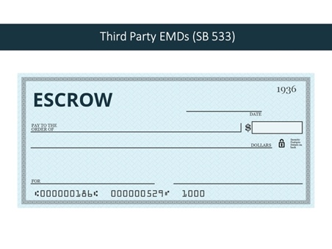 | Another VAR bill, SB 533 addresses the agent’s responsibility when the EMD is going to be held by a third party. If an agent takes possession of an EMD that will not be held in the firm’s escrow account, the agent must ensure that the EMD is delivered to the escrow agent names in the contract by the end of the fifth business banking day following receipt unless otherwise agreed to in writing by the principals to the transaction.  https://lis.virginia.gov/cgi-bin/legp604.exe?221+sum+SB533&221+sum+SB533
Slide 16 |  | Previously, an individual could not act as a mortgage broker and real estate licensee for compensation in the same transaction. Now, if a mortgage broker negotiates, places, or finds a mortgage loan and acts as a real estate salesperson in the same transaction that they secured the loan, they must provide a written disclosure.  https://lis.virginia.gov/cgi-bin/legp604.exe?221+ful+SB303ER+hil
Slide 17 | 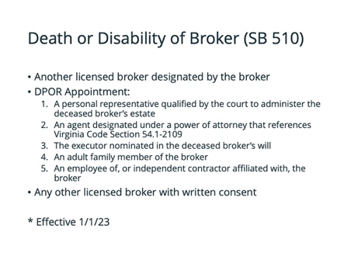 | This is another bill in the VAR legislative agenda. During COVID, VAR received calls from several agents and local associations where the sole broker at the firm had died or entered ICU and was unable to supervise. There was confusion over the status of the firm and agents, and what happened to pending transactions.  Any sole proprietorship or firm where there is only one licensed broker, the broker must designate another licensed broker to carry on the business for up to 180 days for the sole purpose of concluding the business in the event of the broker’s death or disability. This designation must be made at the time the broker applies for licensure. In the event that the broker designated on the license application is unable or unwilling to serve in this capacity, within 30 days of being notified of the death or disability DPOR will grant approval for someone to serve in this role.  Previously, there was a list of 5 categories of people and DPOR was required to go through them in order – first to look and see if there was a personal representative qualified by the court to administer the deceased broker’s estate. If not, then would move on to the next category, and so on.  Now, the law allows DPOR to select someone from any one of the five categories without having to go through them in a particular order. This is good because it is only the fifth and final category where we get to a real estate licensee affiliated with the broker – this meant that a non-licensee could have ended up responsible for winding down the business, including dealing with escrow accounts.  Finally, this bill says that if there are not any individuals in that list that are available or suitable, the VREB may appoint any other licensed broker, with the written consent of that broker.  This is one of the bills that is not effective on July 1 – it goes into effect on January 1, 2023  https://lis.virginia.gov/cgi-bin/legp604.exe?221+ful+SB510ER
Slide 18 | 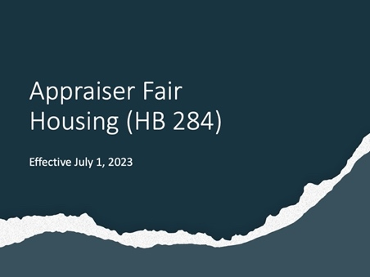 | We know this bill doesn’t directly impact you, but it does impact the industry and your clients – starting July 1, 2023 (so delayed effective date), appraisers will be required to take a minimum of 2 hours of fair housing or appraisal bias courses per license cycle.  https://lis.virginia.gov/cgi-bin/legp604.exe?221+ful+CHAP0118
Slide 19 |  | Instructor: We’re now going to talk about some property management related bills. And for once, there aren’t major changes to the VRLTA!
Slide 20 | 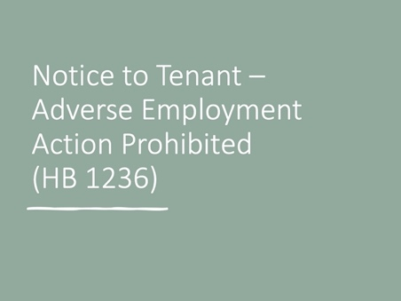 | This new provision requires that in any summons issued in an unlawful detainer matter include a notice to the tenant that it is unlawful for the tenant’s employer to discharge them from employment or take any adverse personnel action against them as a result of their absence from employment due to appearing at any initial or subsequent hearing, provided that they have given reasonable notice to their employer.  https://lis.virginia.gov/cgi-bin/legp604.exe?221+ful+HB1236ER+hil
Slide 21 | 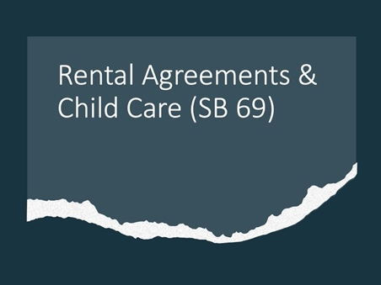 | This bill adds a provision to the VRLTA that allows rental agreements to contain a provision that allows for the operation of child care services provided by the tenant of an apartment building that meet state and local laws and regulations.  https://lis.virginia.gov/cgi-bin/legp604.exe?221+ful+CHAP0267+hil
Slide 22 |  | Instructor: We’re now going to talk about a miscellaneous bill that may be relevant to you, your business, and real property.
Slide 23 | 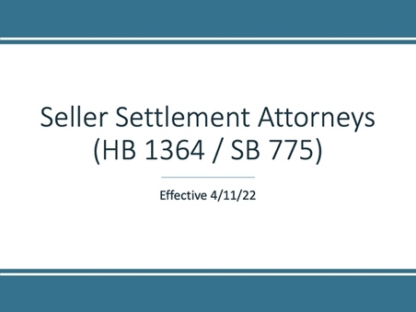 | This is another VAR bill. Many of you may have heard about it, but we still want to cover it.  As most of you know, in February, the Bureau of Insurance released an administrative letter about split settlements – we’re not going to get into all that – Virginia REALTORS® has resources available for you. One question we heard in the days immediately following that letter was whether sellers were allowed to retain an attorney to represent them at settlement.  Because we were so far past the filing deadline for bills, we had to use a special process where every single legislator had to agree to allow for the bill to be introduced. As you can imagine, getting 140 politicians to agree to something isn’t always easy. Because we knew we would have to get 140 votes, we needed to make sure that what was introduced addressed immediate concerns without being controversial. Everyone, including the Bureau of Insurance agreed that any person can hire an attorney to represent them at any time – this includes a seller hiring an attorney to represent them at settlement.  This bill simply reaffirms that in the law so that there is no question.  This bill also contained what is called an “emergency clause” which means it became law as soon as the Governor signed it – in this case, on April 11.
Slide 24 |  | This law requires the DMV to provide information for a manufactured home to a bona fide prospective purchaser or home owner of such manufactured home, real estate agent, title insurer, settlement agent, attorney, manufactured home dealer, manufactured home broker, or loan officer, after filling out a form and paying a fee.  It also prohibits the DMV from disposing of any vehicle information for any manufactured home.  This should make it easier to obtain records related to manufactured homes.  https://lis.virginia.gov/cgi-bin/legp604.exe?221+ful+HB1122ER
Slide 25 |  | This bill requires that a home inspection and report include a determination of whether the home’s smoke detectors are in “good working order.” Currently, home inspectors are only required to note the presence or absence of smoke detectors.  The Board for Asbestos, Lead, and Home Inspectors must also update the regulations to define what “good working order” means.
Slide 26

