Slide 1 | 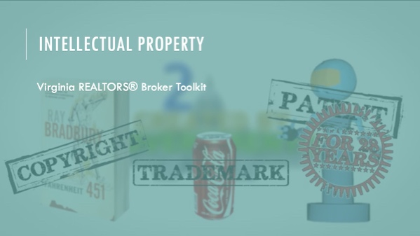 | Instructor: Intellectual property (also known as “IP”) law covers a large range of topics, but the ones that most often affect your lives as real estate professionals are copyright and trademark.
Slide 2 | 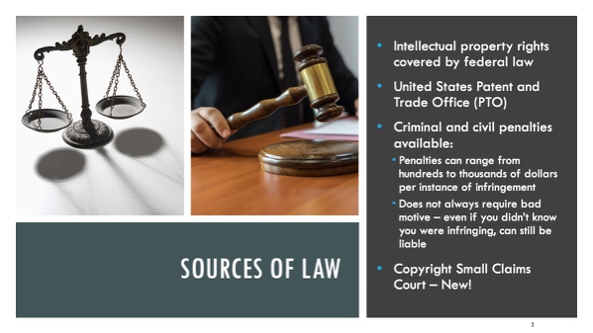 | Instructor: Lots of law that we talk about have multiple regulators, from federal to state to local authorities. However, because of the nature of IP law, the federal government is the only voice on this subject. The United States Patent and Trade Office (or PTO) covers registering various works and marks. If you get caught infringing, you can be subject to criminal and civil penalties that could result in hundreds, if not thousands, of dollars in fines. There’s no requirement that you mean to infringe, so what you intended to do doesn’t matter.  Starting this year there will be a new court to enforce small copyright claims - the Copyright Claims Board, or the CCB, will be a three-judge panel within the U.S. Copyright Office just devoted to hearing “small” copyright claims. It’s designed to provide a faster and cheaper way to enforce the rights of copyright holders. The cost of litigating in federal court was prohibitive and copyright violations have been rampant with the increases in technology over the last 10-15 years. Most notably with the rise of social media. Because filing fees will be smaller and the board will be less formal than a court, it will be easier for you to file infringement claims, but also easier for people to file them against you. Participation is voluntary and you can opt out – see the Virginia REALTORS podcast from November 2021 for more details.
Slide 3 | 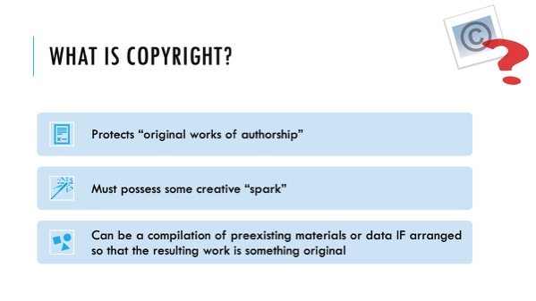 | Instructor: Copyright law is perhaps the most important aspect of IP law for real estate professionals, mostly because it deals with one of the most important tools you have at your disposal for selling a home: photographs. We will discuss photos in depth in a minute. First, the basics. Copyright law exists to protect original, creative works. Copyright covers a range of artistic expressions, from paintings to music to photographs. There has to be some kind of originality involved in the work in order to receive a copyright; just copying stuff down (like in a phone book) isn’t sufficient if there isn’t something in the work that is recognizably yours. One important aspect of copyright law is that you can take a bunch of ingredients that, on their own, would not be protected by copyright, and lump them all together in an expression that is protected. The best examples of this in the real estate world are MLS listings. There are lots of facts in there (number of bedrooms, square footage, etc.) that are not protected, but some have argued that by compiling all of those data points and presenting them in a unique way, MLS listings are subject to copyright law.
Slide 4 | 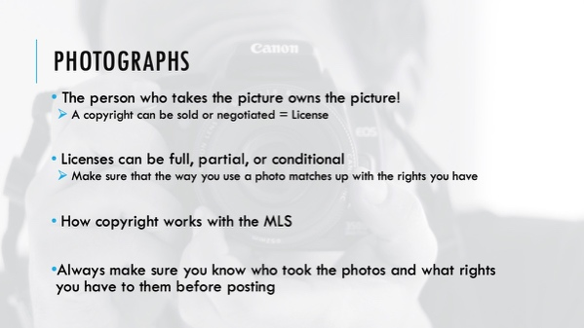 | Instructor: Photographs are one of the areas where copyright law affects your everyday life as a realtor®. Pictures are the lifeblood of MLS listings, but you need to be careful. Photographs, remember, are one of the pieces of “art” that are covered under copyright law. If you use a picture for which you don’t have the correct license, you could be subject to fines and penalties.  Because copyright protects an expression of art, it doesn’t protect the subject of that art. The owner of a property that has been photographed does not own the copyright. Neither does the agent who gets the pictures taken for the listing – at least not automatically. The PHOTOGRAPHER owns the copyright to the photograph. Now, the owner of a copyright is free to sell or trade her right to anyone she wishes. That right, called a license, can take a number of different forms. It can be a complete license (meaning the original owner has no further interest in the work), a partial license (meaning they only give up rights in one area but not others), or a conditional license (I only give up my right to this work if the house goes on the market again, etc.).  You need to pay attention to your MLS rules as well, because many MLSs require the listing agent to give the MLS at least some license to use the photos. So what does this mean? You should make sure to know what rights the MLS expects you to provide, and make sure that your agreement with the photographer allows you at least that much. You may want to consider putting in your agreement with the photographer that you will be granting specific rights to the MLS.
Slide 5 | 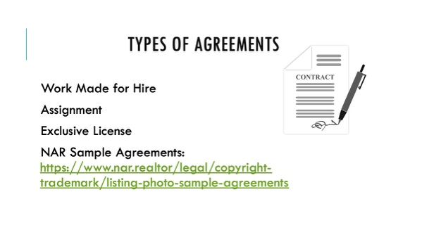 | Instructor: There are different types of agreements you can enter into with a photographer who takes pictures of your listings. Here they range from your complete ownership (Work for Hire) to limited, specific usage (Exclusive or Non-Exclusive License).  Work for Hire – you own the rights to the photos as they’re created, not the photographer  Assignment – photographer assigns all of the rights he/she has in the photo to you, again, the photographer doesn’t retain any rights to the photograph, but there is a difference. Under an assignment, the photograph is able to cancel the agreement after a set period of time (35 years).  Exclusive License – permits your exclusive use of the photographs for real estate purposes, but photographer retains actual ownership  NAR provides you with sample agreements that you can use with a photographer, if that photographer doesn’t have an agreement that they want to use.
Slide 6 | 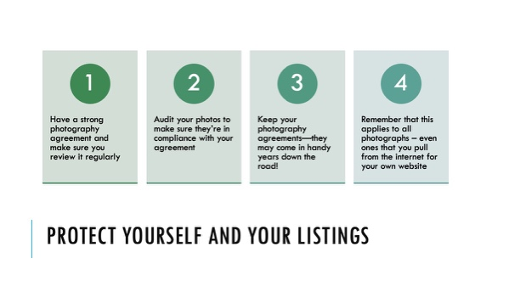 | Instructor: Just like with your brokerage agreements and sales contracts, the best advice here is to make sure you get it in writing! Failing to enforce a copyright won’t necessarily lead to you losing your rights, but it may stop your ability to get damages for past infringements. A copyright can be forfeited by not enforcing a known violation. Also, remember that you shouldn’t pull pictures of things like local landmarks from the internet and slap them on your website without knowing who has the license for those photos.
Slide 7 | 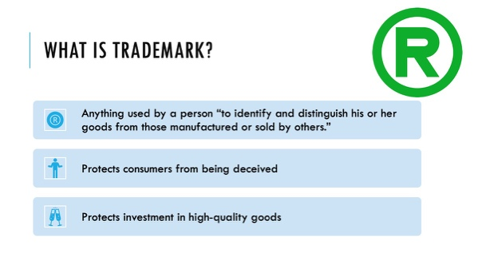 | Instructor: Next, we’re going to discuss trademarks, which is the other big element of IP law as far as we’re concerned in the real estate industry. While copyrights generally exist to protect and encourage the creation of artistic works, trademarks have two main goals: to protect the consumer by ensuring that he knows what he’s getting when he relies upon a specific mark, and to protect corporations and brands by allowing them to trade on their reputation without allowing competitors to move in.
Slide 8 | 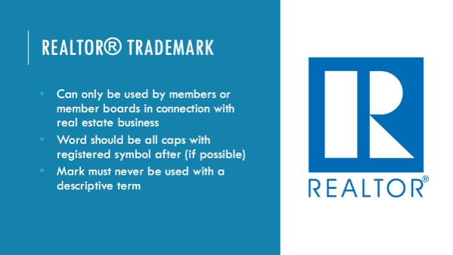 | Instructor: You probably most often encounter a registered trademark in using both the word “Realtor” and the block-R logo. As the holder of the trademark, NAR grants all members a limited license to use the marks in a few specific ways: First, you can only use the mark if you’re a member (or a member board, like Virginia REALTORS. That’s one of the benefits of membership and that exclusivity is what allows people to know that anyone using the mark has agreed to the higher standards set out by NAR. Second, when writing out the word, you should always use all caps and include the registered symbol if possible. If the registered symbol isn’t available for whatever reason, you should at least use all caps. Finally, you need to be careful about how you use the word. The mark should never be used with any descriptive term, like “#1 REALTOR” or “Virginia’s Best REALTOR”.
Slide 9 | 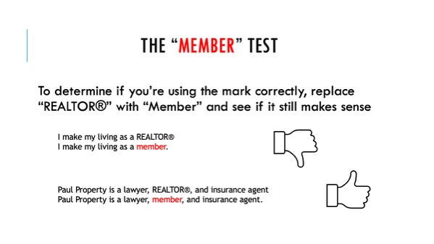 | Instructor: Here’s a simple test to use to make sure that you’re using the mark in the correct way. Replace REALTOR with the word “member’ and see if it still makes sense; if so, you’re using it correctly. Example one - Replacing the mark here with the word “Member” still makes sense, [click] so you’ve used the mark correctly. But example 2 - It doesn’t really make sense to say that you make your living as a member, [click] so you shouldn’t use REALTOR in this context.
Slide 10 | 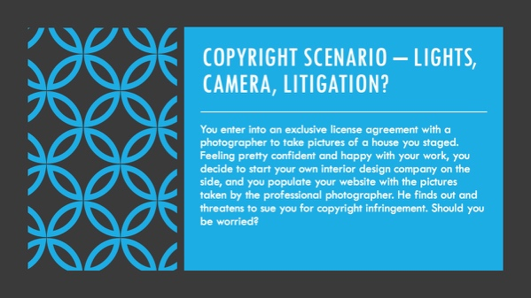
Slide 11 | 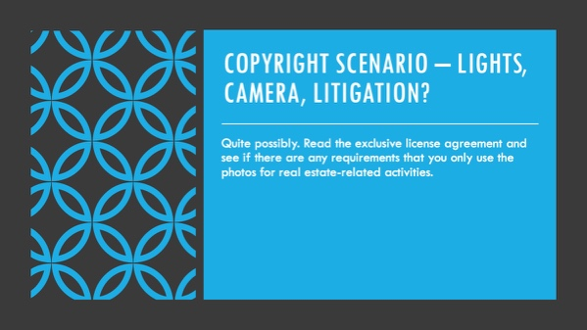 | Instructor: Many forms, including NAR’s sample agreement, specify that the photographer only grants a license for use “in connection with the real estate industry.” Interior design work would probably not be included under that umbrella, which is why it’s always important to read the contract!
Slide 12 | 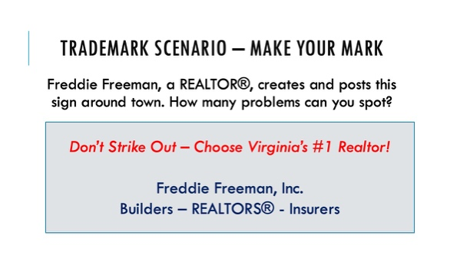
Slide 13 | 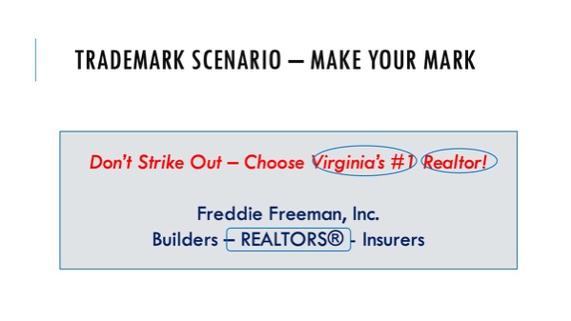 | Instructor: [click] First, he improperly used language to modify the mark, in this case referring to himself as Virginia’s #1 REALTOR. [click] Second, he failed to correctly use all caps and the registered mark symbol when writing out the mark. [click] Finally, and perhaps least obvious, is the tagline at the bottom. While he very well could have meant that his office is stocked with NAR members, using the term like this could cause the consumer to confuse the term REALTORS with “real estate brokers,” so this is not a proper use of the mark.

