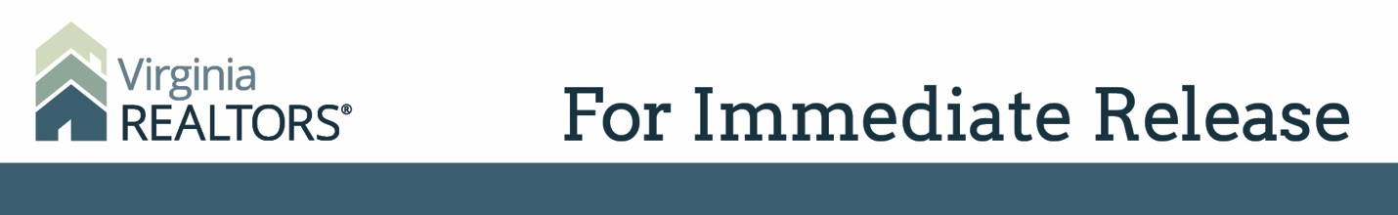

Contact: Robin Spensieri, Communications Director
Email: rspensieri@virginiarealtors.org
Telephone: 404.433.6015
Virginia REALTORS® Supports Victims of Virginia Beach Shooting
The association donates $100,000 to the Virginia Beach Tragedy Fund

Richmond, VA – (June 6, 2019) – Virginia REALTORS® is offering support to the families of those killed in the Virginia Beach Municipal Center shooting on May 31. On June 5, the Virginia REALTORS® Board of Directors unanimously passed a motion to donate $100,000 to the Virginia Beach Tragedy Fund.
This victim assistance fund is administered by the United Way of South Hampton Roads, and 100% of the funds raised will go directly to victims who have been affected by this tragedy.
Virginia REALTORS® extends our deepest condolences to all those who have been affected by this tragedy. We commend the courageous efforts and exceptional response of the Virginia Beach Police Department.
Virginia REALTORS® 2019 President Beckwith Bolle says, “As REALTORS®, we dedicate ourselves to making a difference in our own neighborhoods, as well as all those across the Commonwealth. Our Code of Ethics is a pledge to integrity and community service. We offer our support to those whose lives have been impacted by this tragic event.”
“Virginia REALTORS® is committed to giving back to our community, especially when a senseless tragedy like this hits our members so close to home. Our hearts, prayers, and support are with Virginia Beach during this difficult time,” says Virginia REALTORS® CEO and former Virginia Beach State Delegate Terrie Suit.

# # #

About Virginia REALTORS®
Virginia REALTORS® (previously known as the Virginia Association of REALTORS®) is the largest professional trade association in Virginia, representing nearly 34,000 REALTORS® engaged in the residential and commercial real estate business. Virginia REALTORS® serves as an advocate for homeownership and homeowners and represents the interests of property owners in the Commonwealth of Virginia. For more information, visit www.virginiarealtors.org or follow Virginia REALTORS® on Facebook, Twitter, and LinkedIn. Learn more about the REALTORS® commitment to community here.
NOTE: The term REALTOR® is a registered collective membership mark that identifies a real estate professional who is a member of the National Association of REALTORS® and subscribes to its strict Code of Ethics.

