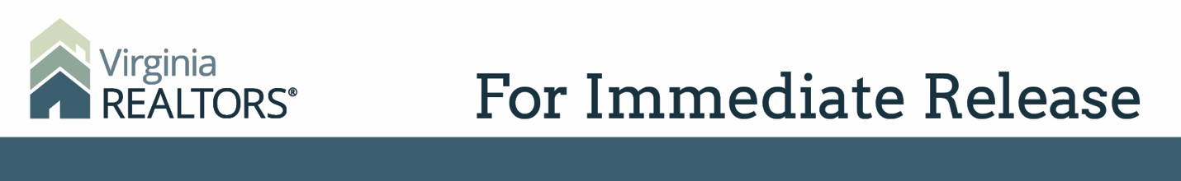

Contact: Robin Spensieri, Communications Director
Email: rspensieri@virginiarealtors.org
Telephone: 404.433.6015
Virginia REALTORS® CEO Will Give Commencement Address for UMW Graduate School
Terrie L. Suit will speak to graduates about the value of leadership

Fredericksburg, VA – (May 3, 2019) – Virginia REALTORS® Chief Executive Officer Terrie L. Suit has been selected to offer the 2019 graduate school commencement address for the students of the University of Mary Washington. The ceremony will take place at 7:30 p.m. on Friday, May 10, 2019.
Suit says, “I am honored and humbled to have been invited to speak at the commencement ceremony for the University of Mary Washington Graduate School. These students are being recognized for an enormous achievement, and I look forward to celebrating them and speaking about the impact they can each make now that they’ve completed their programs.”
Terrie L. Suit is a proud alumna of the UMW Graduate School, earning her MBA from the College of Business.
Suit was appointed as CEO of the Virginia REALTORS® on September 23, 2013. Terrie’s real estate background began in 1985 as a REALTOR® and later transitioned into a twenty-year mortgage lending career.
In 1996, Terrie received a gubernatorial appointment to the Virginia Real Estate Board. Several years later, she was elected to the Virginia House of Delegates, where she served the 81st District for nearly a decade.
In April of 2011, Terrie was appointed by Virginia’s Governor to be Virginia’s first Secretary of Veterans Affairs and Homeland Security. As an Army daughter and a Navy wife, Terrie worked diligently to fulfill the Governor’s goal of making Virginia “the most veteran-friendly state in the nation.”
# # #

About Virginia REALTORS®
Virginia REALTORS® (previously known as the Virginia Association of REALTORS®) is the largest professional trade association in Virginia, representing nearly 34,000 REALTORS® engaged in the residential and commercial real estate business. Virginia REALTORS® serves as an advocate for homeownership and homeowners and represents the interests of property owners in the Commonwealth of Virginia. For more information, visit www.virginiarealtors.org or follow Virginia REALTORS® on Facebook, Twitter, and LinkedIn.
NOTE: The term REALTOR® is a registered collective membership mark that identifies a real estate professional who is a member of the National Association of REALTORS® and subscribes to its strict Code of Ethics.

