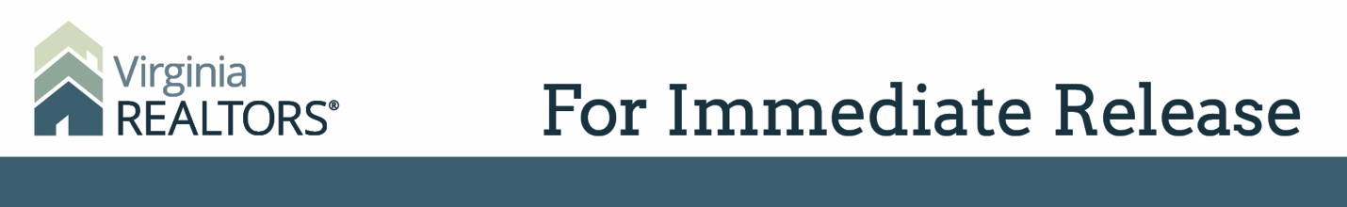

Contact: Robin Spensieri, Communications Director
Email: rspensieri@virginiarealtors.org
Telephone: 404.433.6015

Virginia REALTORS® Chief Economist to Offer Keynote Address at Regional Housing Summit
Dr. Lisa Sturtevant to speak on Fair Housing in Virginia

Charlottesville, VA – (April 12, 2019) – Virginia REALTORS® Chief Economist Dr. Lisa Sturtevant has been selected as the Keynote Speaker for the Charlottesville Regional Housing and Homelessness Summit 2019: Opening the Door. This event was organized by the Thomas Jefferson Planning District Commission and will take place on Friday, April 19 at the Omni Hotel in Charlottesville.

The summit will bring together elected officials and other leaders from the public, private, and non-profit sectors to discuss policy and programmatic tools designed to open the door to housing opportunities for all residents of the region.
Dr. Sturtevant, who authored the 50-year report on the Fair Housing Act for the National Association of REALTORS® last year, will be speaking about the progress of the Fair Housing Act in Virginia. She serves Virginia’s state association of REALTORS® as Chief Economist and is the president and founder of a research firm, specializing in housing studies, affordable housing needs assessments, and program and policy evaluation.
“Access to stable, affordable housing improves educational outcomes for children and better physical and mental health outcomes for all family members. Additionally, local communities and economies grow in strength when there is stable housing available to all residents,” says Sturtevant.

# # #

About Virginia REALTORS®
Virginia REALTORS® (previously known as the Virginia Association of REALTORS®) is the largest professional trade association in Virginia, representing nearly 34,000 REALTORS® engaged in the residential and commercial real estate business. Virginia REALTORS® serves as an advocate for homeownership and homeowners and represents the interests of property owners in the Commonwealth of Virginia. For more information, visit www.virginiarealtors.org or follow Virginia REALTORS® on Facebook, Twitter, and LinkedIn.

NOTE: The term REALTOR® is a registered collective membership mark that identifies a real estate professional who is a member of the National Association of REALTORS® and subscribes to its strict Code of Ethics.

